September | 2021

MILLERTON SCHOOL
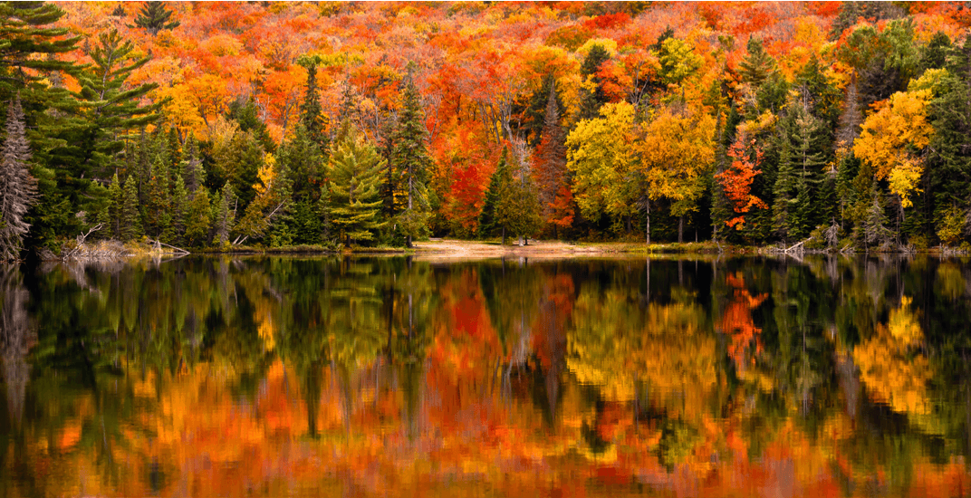
Sunday | Monday | Tuesday | Wednesday | Thursday | Friday | Saturday
 |  |  | 1 | 2 | 3 | 4
5 | 6 | 7 | 8 | 9 | 10 | 11
 | NO SCHOOL  Labour Day | Grades  1, 3, 6 | Grades  2, 4, 5, 7 | Grades  K, 8 | ALL STUDENTS BEGIN
12 | 13 | 14 | 15 | 16 | 17 | 18
 |  | Picture Day |  | Practice  Fire Drill |  | FREE COMMUNITY BBQ  1:00 – 4:00 PM
19 | 20 | 21 | 22 | 23 | 24 | 25
 | Practice Lockdown
26 | 27 | 28 | 29 | 30
 |  | Grade 7  Immunization |  | Orange  Shirt Day

