October
2021
Millerton School – 4711 Route 108 Hwy, Derby, NB E1V5C3 Phone: 627-4090
To get started right away, just click any placeholder text (such as this) and start typing to replace it with your own. Want to insert a picture from your files or add a shape? You got it! On the Insert tab of the ribbon, just tap the option you need. | 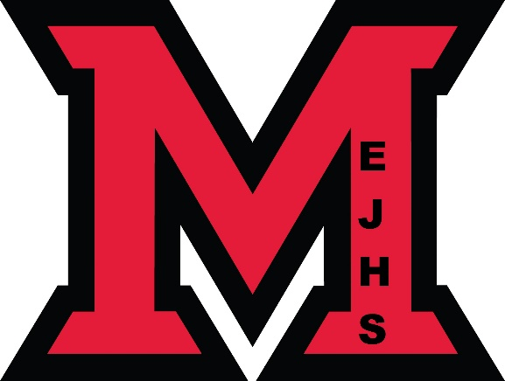
Sunday | Monday | Tuesday | Wednesday | Thursday | Friday | Saturday
 |  |  |  |  | 1 | 2
3 | 4 | 5 | 6 | 7 | 8 | 9
Pictures Due  Fire Prevention  Week Oct 3 -9 | Thanksgiving Food Drive October 4-7  Picture Retakes |  |  | Pizza Orders Due | Pizza Day
10 | 11 | 12 | 13 | 14 | 15 | 16
Kindergarten Registration  Oct 12-22 | NO SCHOOL  Thanksgiving Day |  | Covid – 19  Vaccine Clinic | Pizza Orders Due | Pizza Day
17 | 18 | 19 | 20 | 21 | 22 | 23
 |  |  |  | Pizza Orders Due | Pizza Day
24 | 25 | 26 | 27 | 28  Pizza Orders Due | 29  Pizza Day | 30
31
