Millerton School Newsletter
October 2019

HOT DOGS
We will be selling hot dogs on Wednesday, October 2. Cost is $2.00 per hot dog. We will be taking the orders on Tuesday, October 1. All proceeds will go towards purchasing elementary soccer jerseys. Thanks in advance!!
THANKSGIVING FOOD DRIVE
Once again this year our students will be helping to make a difference in the lives of under resource families in our community by donating to our Thanksgiving Food Drive. Please send non-perishable food items with your child any day from October 7-11th. This is a great opportunity to explain to your child how much they really have to be thankful for and their responsibility to help others less fortunate around them.
MORNING ARRIVAL
If student arrives after 8:15 am they are to go to the breakfast or walking program. They are not to go upstairs after 8:15 am. Thanks for your cooperation in this matter.
SOME FRIENDLY REMINDERS
If there is a change to your child’s regular day plan, (going somewhere else other than home, being picked up, etc.) then a note (with person’s name and civic address) must be sent to the homeroom teacher each day. Calling the school in the afternoon should only be used in case of an emergency.
SIGNING BOOK

Please remember when you are picking up or dropping off your child during school hours that you must come in and sign your child in or out, at the office.

FIRE PREVENTION WEEK OCTOBER 6 - OCTOBER 12

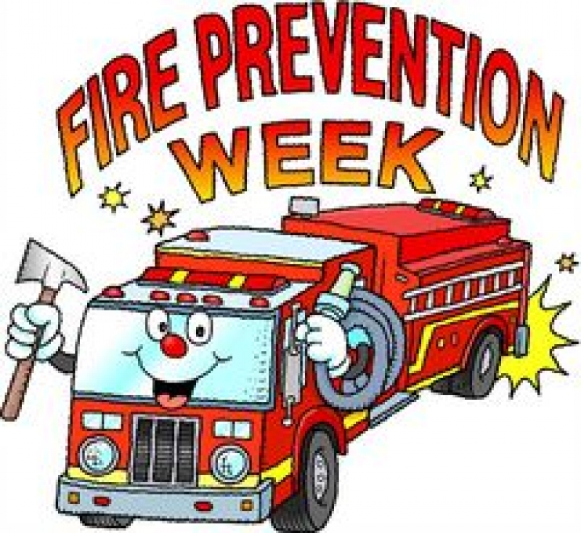

PICTURE DAY

Lifetouch will be here on Monday, October 7th for picture day.

KINDERGARTEN REGISTRATION WEEK OCTOBER 15– OCTOBER 18

Registration for children entering Kindergarten in September 2020 will be held from October 15th – 18th at you community school. If you have a child entering Kindergarten next year, visit the main office between 8:00 am – 3:00 pm to have him or her registered. Proof of immunization, birth certificate and medicare card are required at the time of registration. It is important that your child be registered at this time in order to receive information needed for pre-school screening and successful transition into school for September 2020.
IMMUNIZATION

Our Public Health Department will be at our school on Friday, October 18th for our Grade 7 Immunization.

HALLOWEEN DANCE

There will be a Halloween Dance on Thursday, October 24th for our students in grades 5-8 from 6-8 PM. There will be prizes awarded for the best costume! Cost $3.00/$2.00 with costume!

TERRY FOX WALK
Our Terry Fox Walk was a huge success. Our total raised was $150.00. A special thank you to our students, staff and all of the parents for their kind donations.
SKATING
Skating will begin in November. Students are reminded to dress appropriately. Helmets are Mandatory.
We also have some extra skates and helmets at the school if there is anyone who would like to use these items.
DATES TO REMEMBER – NO SCHOOL: October 14–Thanksgiving Day
HOME AND SCHOOL MEETING

This month our home and school meeting will be Tuesday, October 1st at 7:00 pm. Everyone is welcome to attend.

