October | 2019

MILLERTON SCHOOL
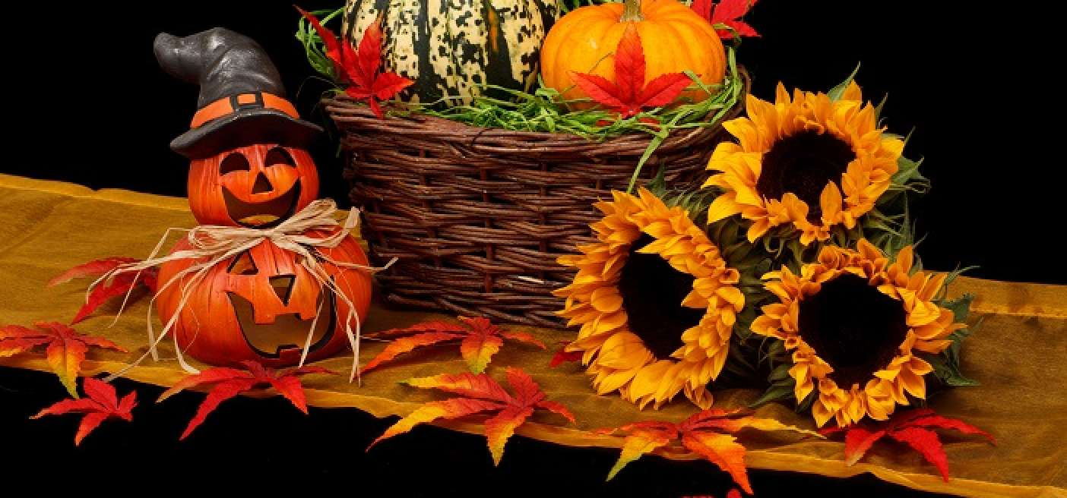
Sunday | Monday | Tuesday | Wednesday | Thursday | Friday | Saturday
 |  | 1 | 2 | 3 | 4 | 5
 |  | Hot Dog  Orders Due  Home & School Meeting 7:00 pm | Hot Dog  Day | Pizza Orders Due | Pizza Day
6 | 7 | 8 | 9 | 10 | 11 | 12
Fire Prevention Week Oct 6-12 | Picture Day  Food Drive  Oct 7 - 11 |  |  | Pizza Orders Due | Pizza Day
13 | 14 | 15 | 16 | 17 | 18 | 19
 | NO SCHOOL  Thanksgiving Day | Kindergarten Registration  Oct 15 - 18 |  | Pizza Orders Due | Pizza Day  Grade 7 Immunizations
20 | 21 | 22 | 23 | 24 | 25 | 26
 |  |  |  | Pizza Orders Due  Halloween  Dance 6-8 pm | Pizza Day
27 | 28 | 29 | 30 | 31
 |  |  |  | Pizza Orders Due  Happy Halloween | Millerton School  (506)627-4090  Fax: (506)627-4500

