Millerton School Newsletter
October 2018

PRINCIPALS MESSAGE
Firstly I want to thank the Millerton school community for its help and support; we have parents and community members that are volunteering with our breakfast program, we have had families bringing in garden vegetables for our snacks and we have had parents fill roles as coaches and mentors. That is great, the best way to show our students that we value education and taking care of each other is by being a visible model. That being said we can always use more help. We have students who are in need of mentors, tutors and role models. On the academic side, one of the keys to success is communication between home and school. If you have a concern, a question or if you want to check in your child’s subject teacher is your first contact. Don’t wait, it is a partnership with your child’s success as everybody’s goal.
THANKSGIVING FOOD DRIVE
Once again Millerton School will be having a Thanksgiving Food Drive to collect non-perishable food items for those in our community who are less fortunate. Collections will take place from Monday, October 1st through until Thursday, October 4th. Students will be trying to fill two bins in our cafeteria this year. Please do your part! Thank you for your support.
Millerton School: The Little School with the Big Heart!
MORNING ARRIVAL
If student arrives after 8:15 am they are to go to the breakfast or walking program. They are not to go upstairs after 8:15 am. Thanks for your cooperation in this matter.
SOME FRIENDLY REMINDERS
If there is a change to your child’s regular day plan, (going somewhere else other than home, being picked up, etc.) then a note (with person’s name and civic address) must be sent to the homeroom teacher each day. Calling the school in the afternoon should only be used in case of an emergency.
SIGNING BOOK

Please remember when you are picking up or dropping off your child during school hours that you must come in and sign your child in or out, at the office.

FIRE PREVENTION WEEK OCTOBER 7 - OCTOBER 13
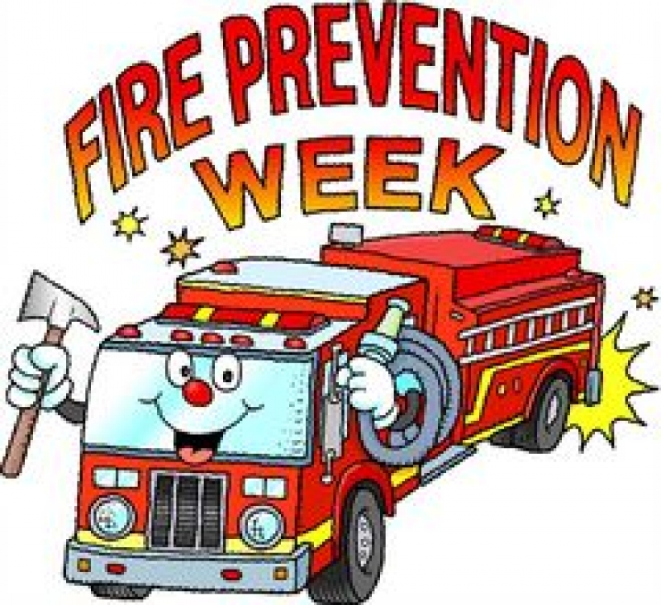
PICTURE RETAKES

Harvey Studios will be here on Tuesday, October 9th for picture retakes.

KINDERGARTEN REGISTRATION WEEK OCTOBER 9– OCTOBER 12

Registration for children entering Kindergarten in September 2019 will be held from October 9th – 12th at you community school. If you have a child entering Kindergarten next year, visit the main office between 8:00 am – 3:00 pm to have him or her registered. Proof of immunization, birth certificate and medicare card are required at the time of registration. It is important that your child be registered at this time in order to receive information needed for pre-school screening and successful transition into school for September 2019.
IMMUNIZATION

Our Public Health Department will be at our school on Monday, October 22nd for our Grade 7 Immunization. Please remember to return consent forms. These forms will be sent home shortly.

HALLOWEEN DANCE

There will be a Halloween Dance on Thursday, October 25th for our students in grades 5-8 from 6-8 PM. There will be prizes awarded for the best costume! Cost $3.00/$2.00 with costume!

TERRY FOX WALK
Our Terry Fox Walk was a huge success. Our total raised was $150.00. A special thank you to our students, staff and all of the parents for their kind donations.
SKATING
Skating will begin in November. Students are reminded to dress appropriately. Helmets are Mandatory.
We also have some extra skates and helmets at the school if there is anyone who would like to use these items.
DATES TO REMEMBER – NO SCHOOL: October 8–Thanksgiving Day
HOME AND SCHOOL MEETING

This month our home and school meeting will be Monday, October 15th at 7:00 pm. Everyone is welcome to attend.
A Halloween event is being planned for Friday, October 26th. More details to follow.

