Millerton School Newsletter
October 2017

THANKSGIVING FOOD DRIVE
Once again Millerton School will be having a Thanksgiving Food Drive to collect non-perishable food items for those in our community who are less fortunate. Collections will take place from Monday, October 2nd through until Friday, October 6th. Our goal this year is to have 200 items! Please do your part.
Millerton School: The Little School with the Big Heart!
SOME FRIENDLY REMINDERS
If there is a change to your child’s regular day plan, (going somewhere else other than home, being picked up, etc.) then a note (with person’s name and civic address) must be sent to the homeroom teacher each day. Calling the school in the afternoon should only be used in case of an emergency.
PARKING LOT

We are asking all parents who visit our school to take extra care and precaution and to refrain from parking in front of the school. Our Phys Ed. Classes are outside in the morning and afternoon and use the paved areas.
It is important that we remember that when our students are outside they play with a free spirit that makes them feel invincible, so it is up to us to look out for them and keep them safe.

Please use the side parking lot and refrain from driving to the front of the building.

SIGNING BOOK

Please remember when you are picking up or dropping off your child during school hours that you must come in and sign your child in or out, at the office.

ELEMENTARY CROSS COUNTRY
There are meets for elementary cross country on the following dates and times for October:
Oct 4 – Heritage Park (Metepenagiag) at 4:00 pm Oct 11– Gretna Green School at 4:00 pm

FIRE PREVENTION WEEK OCTOBER 8 - OCTOBER 14
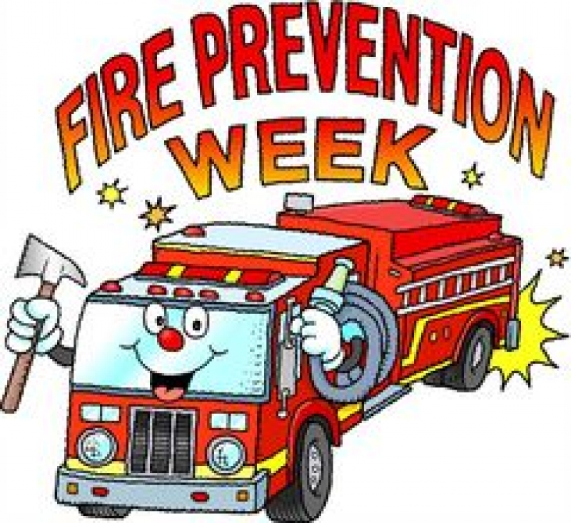
GYM ACTIVITIES

Monday – Soccer/Cross Country
Tuesday and Thursday – Survivor – Dress for the Weather Outdoors
Wednesday – K-2 You and Your World – Grade 3-8 Health
Friday – Game Day – Do not need to change on this day

HOT LUNCH FRIDAYS

This year we have partnered with Pizza Delight and will have pizza slices every Friday. Cost is $3.00 per slice or 2 slices for $5.00. We need to know by Thursday how many slices your child would like and also must be paid for on Thursdays when we take the orders, this way we know many pizzas to order. So far this program is running very well and everyone is enjoying Pizza Fridays.

PICTURE RETAKES

Harvey Studios will be here on Monday, October 23 for picture retakes.

KINDERGARTEN REGISTRATION WEEK OCTOBER 10– OCTOBER 13

Registration for children entering Kindergarten in September 2018 will be held from October 10th – 14th at you community school. If you have a child entering Kindergarten next year, visit the main office between 8:00 am – 3:00 pm to have him or her registered. Proof of immunization, birth certificate and medicare card are required at the time of registration. It is important that your child be registered at this time in order to receive information needed for pre-school screening and successful transition into school for September 2018.

HALLOWEEN DANCE

There will be a Halloween Dance in October for our students in grades 5-8 from 6-8 PM. There will be prizes awarded for the best costume! Cost $3.00/$2.00 with costume! Date to be determined.

TERRY FOX WALK
Our Terry Fox Walk was a huge success. Our total raised was $113.20. A special thank-you to Ms. Hayes, The Renous-Quarryville Fire Department, Students, Staff and all of the Parents for their kind donations.
SKATING
Skating will begin in November. Students are reminded to dress appropriately. Helmets are Mandatory.
We also have some extra skates and helmets at the school if there is anyone who would like to use these items.

HALLOWEEN WALK
There will be a Halloween Walk in the woods on Tuesday, October 31st at 1:00 pm.
DATES TO REMEMBER – Early Dismissal – October 25 – 11:30 am
NO SCHOOL: October 10–Thanksgiving Day

HOME AND SCHOOL MEETING

This month our home and school meeting will be Wednesday, October 11 at 7:15 pm. Everyone is welcome to attend.

Home and School Movie night will be on Friday, October 20. More details to follow.

