OCTOBER 2017
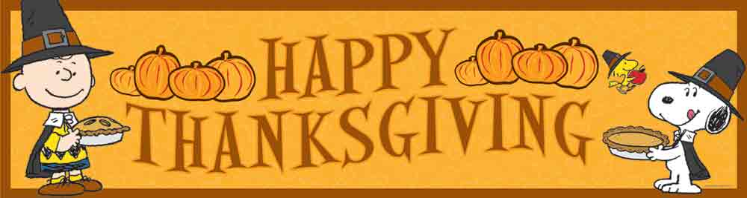

SUNDAY MONDAY TUESDAY WEDNESDAY THURSDAY FRIDAY SATURDAY
1 | 2 | 3 | 4 | 5 Pizza Orders Due | 6  Pizza Day | 7
8 | 9  THANKSGIVING FOOD DRIVE  Thanksgiving Day  NO SCHOOL | 10 | 11 | 12  Pizza Orders Due | 13  Pizza Day | 14
15 | 16  Elementary Soccer Jamboree at NSEE  Details to Follow | 17  KINDERGARTEN REGISTRATION  Home & School Meeting  7:15 pm | 18 | 19  Pizza Orders Due | 20 Pizza Day  Home & School Halloween Movie Night  Details to Follow | 21
22 | 23  Picture Retakes | 24 | 25 PJ DAY  Professional Learning Day  Early Dismissal 11:30 am | 26  Pizza Orders Due | 27  Pizza Day | 28
29 | 30  Haunted Halls Literature Hour | 31 Walk in the Woods 1:00 pm  Happy Halloween

Millerton School: 4711 Route 108 Hwy Derby, NB. E1V-5C3. Principal: Tom McCabe, Phone # 627-4090
Dates to Remember for November: No School –November 10 – PD Day, November 13th – Remembrance Day and No School November 24th – Parent Teacher Interviews.

