November 2017

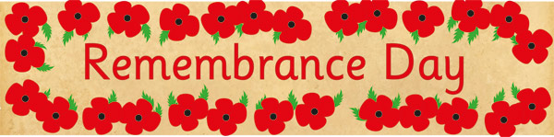
SUNDAY MONDAY TUESDAY WEDNESDAY THURSDAY FRIDAY SATURDAY
 |  |  | 1 | 2  Pizza Orders Due  Skating  K-4  Bus will leave at 8:45 am | 3 Pizza Day  Hat Day -$1.00  Proceeds SPCA  Bears Den  7 - 10:00 pm  Middle School Students | 4
5 | 6 | 7 | 8 | 9  Remembrance Day Service  8:45 am  Wear Red | 10  NO SCHOOL  Professional Learning Day | 11  Remembrance Day
12 | 13  NO SCHOOL  In Lieu of Remembrance Day | 14  Eye – Da  Testing  Pre-K Students | 15 | 16  Pizza Orders Due | 17 Pizza Day  Skating Gr 5-8  Bus will leave at 8:45 am  Bears Den  7 – 10:00 pm  Middle School Students | 18
19 | 20 | 21 | 22  Report Card Day | 23  Parent Teacher Interviews  5:00-7:00 pm | 24  NO SCHOOL  Parent Teacher Interviews  9:00-11:30 am | 25
26 | 27 | 28 | 29 | 30  Pizza Orders Due | December 1  Pizza Day

Millerton School: 4711 Route 108 Hwy Derby, NB. E1V-5C3. Principal: Tom McCabe, Phone # 627-4090
Dates to Remember for December: Christmas Concert – December 20
at 9:00 am. Last Day of Classes December 22, 2017.

