November | 2020

MILLERTON SCHOOL
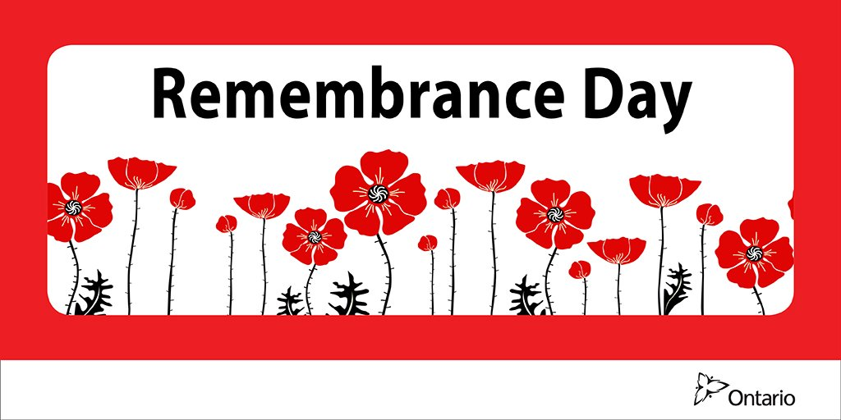
Sunday | Monday | Tuesday | Wednesday | Thursday | Friday | Saturday
 |  |  |  |  | Pizza Day  Skating K-3  8:45 am  Picture Retakes  Tickets Due | Home & School  Breakfast  8-11 am  Everyone Welcome  Jersey Draw
1 | 2 | 3 | 4 | 5 | 6 | 7
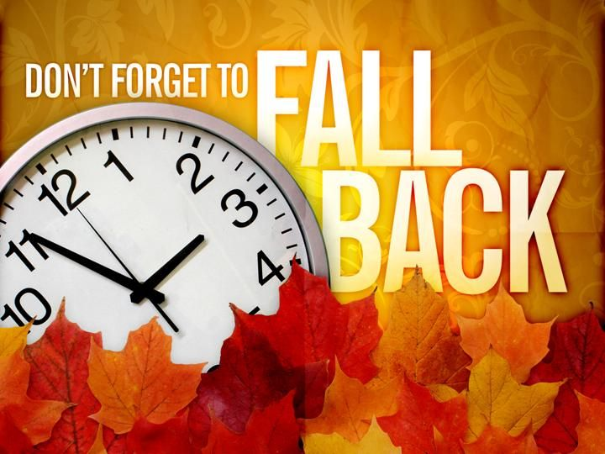 |  |  |  | Pizza Orders Due  All Picture  Orders Due | Pizza Day
8 | 9 | 10 | 11 | 12 | 13 | 14
 |  |  | NO SCHOOL  Remembrance Day | Pizza Orders Due | Pizza Day  Picture Retakes | 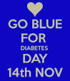
15 | 16 | 17 | 18 | 19 | 20 | 21
NO SCHOOL
Professional Learning Day
22 | 23 | 24 | 25 | 26 | 27 | 28
 |  |  |  | Pizza Orders Due | Pizza Day
29 | 30

