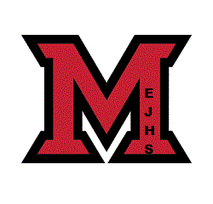

Millerton Positive Learning Environment Plan

2015

Our school mission:
Millerton School strives to educate the whole child by building CHARACTER, KNOWLEDGE, and OPPORTUNITIES to practice these skills.

Goals:
1) Create a positive learning environment following the Bucket filling philosophy ensuring that there is an atmosphere that is nurturing.
-plan of action- reinforce the principles of Bucket filling school wide and celebrate successes while creating opportunities for growth.
2) Develop Whole Body Listeners.
-plan of action- Guidance will introduce the concept to the classes and teachers will incorporate it into classroom procedures. We will reinforce the concepts by incorporating the language in to school culture.
3) Students will increase their mental fitness by developing strategies to better control their anxieties and angry feelings.
-plan of action- two prong approach a) classroom sessions introducing skills and strategies b) targeted individualized sessions for students and small groups with specific techniques.

Student code of conduct
At Millerton we have adopted the bucket fillers pledge as our student code of conduct.
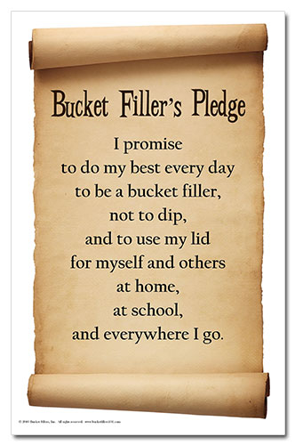
Bucket filling program
It’s simple: Everyone has an invisible bucket. This bucket represents a person’s mental and emotional health or self-concept. When someone does something kind, they fill your bucket. But more importantly, they fill their own bucket too. We fill buckets when we express encouragement, help, and friendship to others. Conversely, we can also dip from others buckets and our own by using unkind words and making poor choices.
Bucket filler of the week.
We have mini-buckets placed in every classroom and at the main office. Students and staff are able to identify individuals that they have witnessed being a bucket filler. We celebrate during the walking program on Friday morning by drawing a bucket filler of the week. This person is celebrated and receives a gift certificate and a bucket filling certificate.

Peacekeeper program
Our peacekeeper program is targeted at our Middle School students, with our guidance counsellor training and managing the program. The goals of a Peacekeeper are: to be a good listener, to work well on a team with another Peacekeeper, to be fair, to be a helper, to be a dependable person, and to be someone who can be trusted. As you can imagine, it takes a lot of training and experience to be able to help others work out conflicts. The Peacekeepers have a rotating schedule and take turns working in pairs during the lunch hour recess.
Guidelines for our peacekeepers:
• “I” Messages: the essential communication tool
• “The Clean Up”: taking students beyond, “I’m sorry”

• “Stop & Breathe”: an important decision making and de-escalation skill
• Teamwork: through several activities, students will learn the value of working together
• Leadership: peacemakers learn about their role as leaders
Buddy Bench
Our peacekeepers also developed and man our Buddy bench. If a student feels that need a buddy they can come to the bench and that will allow the peacekeepers to help them deal with an issue should they have one. It will also make it possible for other students to recognize that they need someone to play with and give them the opportunity to help out.
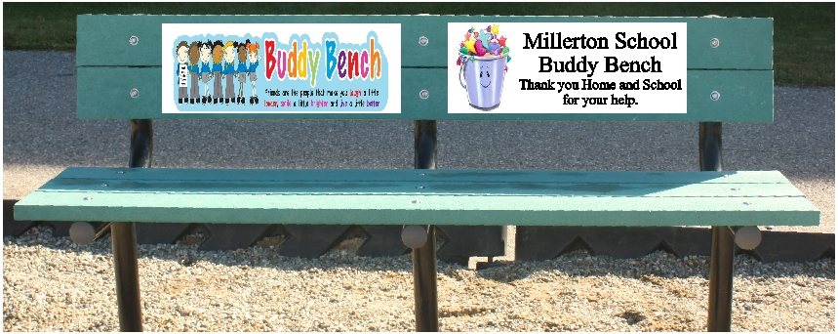

Whole body listening

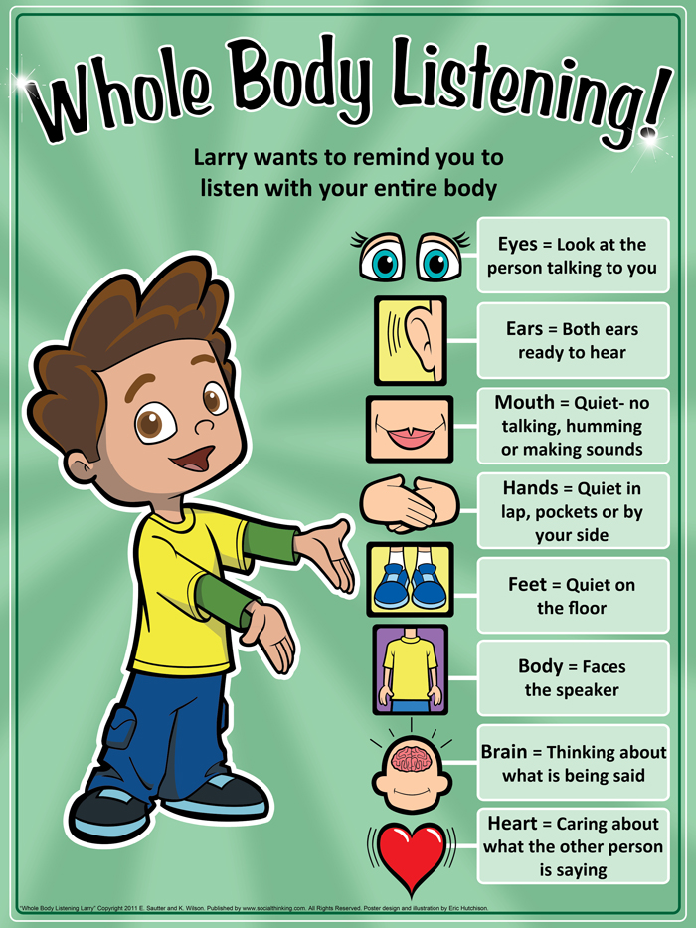
The whole body listening program focuses on teaching preschool and young elementary school students to use their:
•eyes to look at the person talking
•ears to hear what is being said
•mouth by remaining quiet
•hands by keeping them by their side or in lap
•feet by placing them on the floor and keeping them still
•body by facing the speaker or sitting in chair
•brain to think about what the speaker is saying
•heart to care about what the speaker talks about

Beyond the hurt
Beyond the Hurt is based on the belief that all youth—those targeted, those who bully, and bystanders—have a critical role in preventing bullying.
Most people involved in the bullying dynamic are bystanders, silently watching from the sidelines. Beyond the Hurt gives youth and adults the tools to take a stand to stop bullying before it starts.
At Millerton we have a beyond trained group in our middle school. They use their training in conjunction with their roles.
Positive environment initiatives:

Pyramid of interventions
Bucket filling program
Whole body listening
Star of the week
Walker of the week
Bucket filler of the week
Attendance awards
Most improved student awards
Positive attitude awards
Courtesy Awards
Breakfast program
Wellness grants
Lunch group
Mediation and restitution
Fishing club
Fly tying club
Intermural
Turn around achievement award

Daily Meeting Initiative
One of our strongest Positive Learning Environment initiatives is the scheduling of daily morning meetings. These meetings involve half the staff on a rotating basis, they take place first thing in the morning and provide an opportunity to update staff on immediate issues, provide feedback and monitor programs and make all responses immediate.

