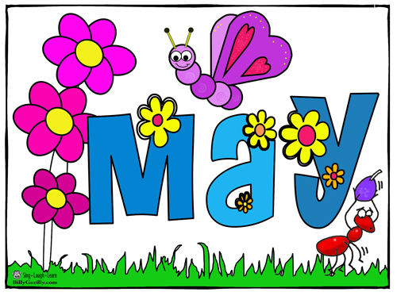

SUNDAY MONDAY TUESDAY WEDNESDAY THURSDAY FRIDAY SATURDAY
 |  | 1 | 2 | 3  NBTA Meetings  NO SCHOOL  Math Competition | 4  Council Day  NO SCHOOL | 5
6 | 7 | 8 | 9 | 10 KC Orders Due | 11 KC & Sons  Jump Rope for Heart Kick-Off  1:00 pm | 12
13 | 14 | 15 | 16 | 17  Pizza Orders Due | 19  Pizza Day | 20
20 | 21  Victoria Day  NO SCHOOL | 22  Please return all tickets | 23 Ticket Draw  Elementary Archery Competition Max Aitken 12:00 pm | 24 KC Due  Middle School Archery Competition Max Aitken 12:00 pm | 25  KC & Sons | 26
27 | 28 | 29 | 30  Professional  Learning Day  Early Dismissal 11:30 am | 31  Pizza Orders Due | 1 Pizza Day  Grade 3, 4 & 5  Fish Release Doaktown Salmon Museum

Millerton School: 4711 Route 108 Hwy Derby, NB. E1V-5C3. Principal: Tom McCabe, Phone # 627-4090
Dates to Remember for June: Grade 8 Banquet – June 11 at 6:00 pm.
Middle School Prom – June 14. Last Day of Classes – June 22

