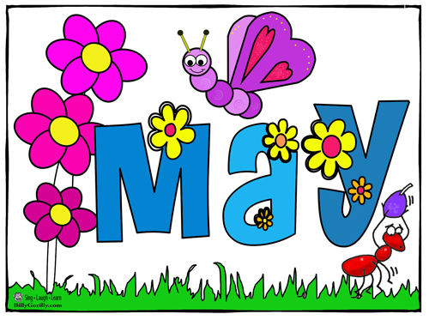

SUNDAY MONDAY TUESDAY WEDNESDAY THURSDAY FRIDAY SATURDAY
 | 1 | 2  Mad Science  Lunch Time | 3 | 4  NBTA Meetings  NO SCHOOL | 5  Council Day  NO SCHOOL | 6
7 | 8 | 9  Mad Science  Lunch Time | 10  Return Forms for  Dr. Keating Kids’ Run | 11 | 12  Math Competition UNB  Mother’s Day Draw | 13
14 | 15 | 16  Mad Science  Lunch Time | 17 | 18 | 19  Jump Rope for Heart  1:00 pm  Popcorn Day | 20
21 | 22  Victoria Day  NO SCHOOL | 23  Mad Science  Lunch Time | 24 | 25 | 26 | 27
28 | 29 | 30  Mad Science  Lunch Time | 31

Millerton School: 4711 Route 108 Hwy Derby, NB. E1V-5C3. Principal: Tom McCabe, Phone # 627-4090
Dates to Remember for June: Middle School Formal – June 8
Grade 8 Banquet – June 15 at 6:00 pm
Last Day of Classes – June 23

