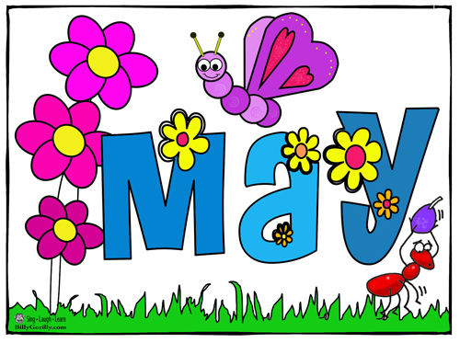

SUNDAY MONDAY TUESDAY WEDNESDAY THURSDAY FRIDAY SATURDAY
1 | 2 | 3  Please return tickets for Mother’s Day Draw | 4  Mother’s Day Draw | 5  NO SCHOOL  NBTA Meetings | 6  NO SCHOOL  NBTA Council Day | 7
8 | 9 | 10 | 11 | 12  Chef Program | 13 | 14
15 | 16  Go for 42  Begins | 17 | 18 | 19  Chef Program  Jump Rope For Heart Kick-Off  1:00 pm | 20 Popcorn  $1.00 | 21
22 | 23  NO SCHOOL  Victoria Day | 24 | 25 | 26  Chef Program | 27  NO SCHOOL  Professional Learning Day | 28
29 | 30 | 31

Millerton School: 4711 Route 108 Hwy Derby, NB. E1V-5C3. Principal: Tom McCabe, Phone # 627-4090
Dates to Remember for June: Middle School Formal-June 9, Grade 8 Banquet June 14 @ 6:00 pm. Last Day of School – June 24

