March | 2022

Millerton School
Sunday | Monday | Tuesday | Wednesday | Thursday | Friday | Saturday
 |  | 1 | 2 | 3 | 4 | 5
 |  | Winter Carnival Activities | Winter Carnival Activities | Winter Carnival Activities | Winter Carnival Activities  All Lotto Sheets Due Back for Fundraiser
6 | 7 | 8 | 9 | 10 | 11 | 12
 | M  B | A  R | R  E | C  A | H  K
13 | 14 | 15 | 16 | 17 | 18 | 19
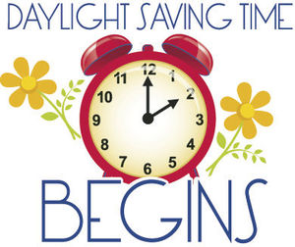 | Welcome  Back!! | No School for Kindergarten Students Only | Lotto Fundraiser Begins  Popcorn $1.00 | Pizza Orders Due  Wear Green  for St. Patrick’s Day | Pizza Day
20 | 21 | 22 | 23 | 24 | 25 | 26
Spring  Begins |  |  | Popcorn $1.00 |  | NO SCHOOL  K-8 Students  PL Day
27 | 28 | 29 | 30 | 31
 |  |  | Popcorn $1.00 | Pizza Orders Due

