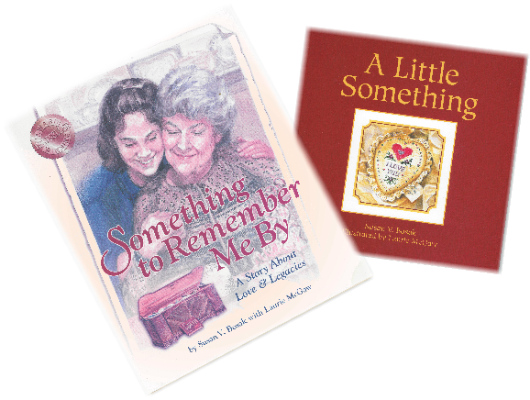
.. the little things that
matter most and make
the memories that
endure- a smile, a hug,
a simple touch of the hand

True story about love
and legacies that inspires
you each time you read it.

Millerton CALNet Center in co-operation with the Millerton School will be selling 2 Legacy Books to raise funds for supplementing our books in classrooms and library.
These books are beautiful little treasures of legacies passed down in generations. They are both hard cover, with dust jackets and make a beautiful Mother's Day, Grandparent's Day, Birthday or just to say Thank you gift.
They can be ordered as a set of 2 or alone.
Set: $25. each
Single copy: $15. each

You may order by: 627-0503
email: CAL.Millerton@gnb.ca
Order must be paid in full before order is made.
All profits will go to purchase books for classrooms and library to give our students more variety and availability to reading material.

