MILLERTON SCHOOL 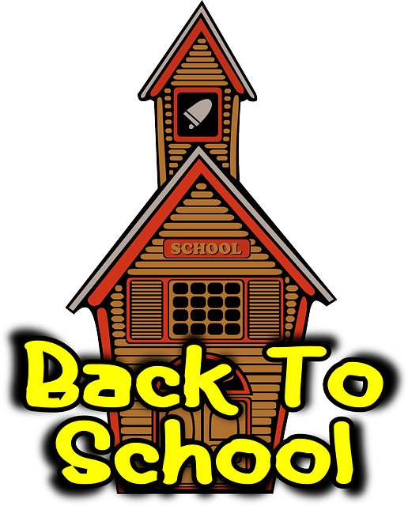 Grade K/1 Supplies

2022-2023

pencils

2 boxes markers

1 box 24 crayons

scissors

pencil case

4 glue sticks

4L ice cream container to hold supplies

Indoor Sneakers

Change of clothes to be left at school

Large zip lock bag for Library Book



OTHER

1 pack Hilroy scribblers

2 plastic folders with pockets inside

Binders and Duotangs are color coded and can be labelled before arrival at school in September. Please DO NOT put loose leaf paper in them.

Please mark your child’s name on all personal belongings- sneakers, lunch bag, book bag and jackets as many come to school with identical items. THANKS😊

DUOTANGS

LITERACY- yellow

SPELLING- orange

READING LOG- red

BINDERS

MATH- blue

WRITING- black

HOMEWORK- red