Millerton School
Kindergarten/Grade 1
2024-2025

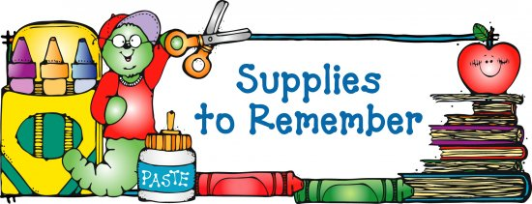

- $50.00 for School Supplies
- Full – Size Book Bag
- Lunch Can
- 3 boxes of Kleenex
- 1 Box of Large Ziplock Baggies
- 1 Box of Sandwich Baggies
- Flip Top Water Bottle
- 1 pair of sneakers (for indoors and gym)
- 1 change of clothes to be kept at school (in a bag with their name on it)
- Please have your child’s name marked on all their belongings especially sneakers, book bags, lunch cans and jackets as many students come with identical items.

