1 package of pencils

2 boxes of markers- not “Fine Tip”

1 box of crayons

3 large glue sticks

1 eraser

scissors

1 4L ice cream container to hold supplies

\*Please have extra supplies at home to use for “HOMEWORK”

2 boxes Kleenex

Indoor sneakers

Large Zip Lock Bag for LIBRARY book

Change of clothes to be kept at school

 MILLERTON SCHOOL

KINDERGARTEN SUPPLIES 2021-2022

WELCOME to SCHOOL

\*PLEASE put your child’s name on their personal belongings-especially sneakers-lunch cans-book bags-jackets-as many come to school with identical items-THANK-YOU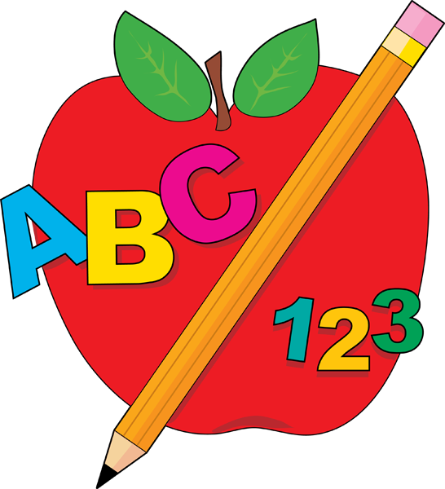

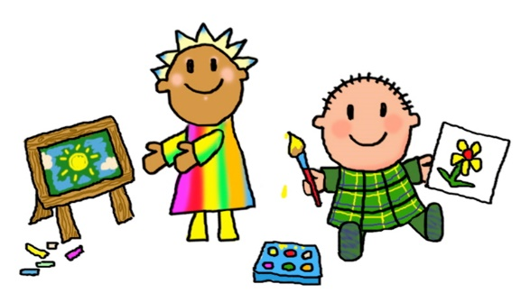 Have a GREAT Summer! 

FOLDERS

3 plastic folders

(2 pockets inside)

BINDERS

MATH- blue

WRITING- red

PRINTING- black

HOMEWORK- red

SCRIBBLERS

1 pack (of 4) Hilroy scribblers (no coiled scribblers)

DUO-TANGS

1 black

1 orange

1 blue

2 yellow