Millerton News
June 2018
Principal: Tom McCabe
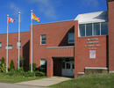

UNB MATH COMPETITION

Congratulations to Dustin Stewart and Alex Stewart for competing in the Math Competition. Well Done!

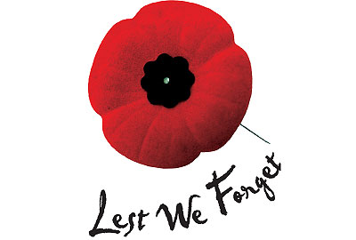
SPEEDWAY MIRAMICHI TICKETS
Congratulations to Max Green for winning the Speedway Miramichi Tickets and a big thank you to everyone who gave their support.

TURNAROUND ACHIEVEMENT AWARD

A Big Congratulations to Lauren Kelly in the grade 6 class who will be receiving the Turnaround Achievement Award on June 12, 2018.

SPELLING BEE
Our school spelling bee will be held on Friday, June 4. Good luck to everyone!
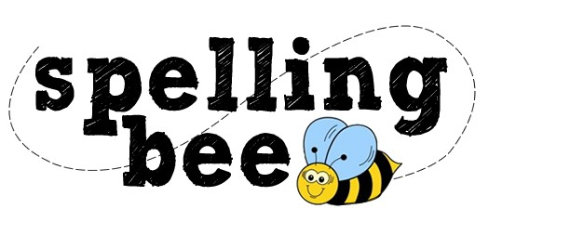
HOME AND SCHOOL NEWS
K-4 FIELD TRIP

Our K – 4 students will be going to MVHS for swimming and to Dairy Queen for lunch and bowling on Friday, June 15. The bus will leave the school at 8:30 am. Snacks and lunch will be provided. Students will be back to the school by 2:00 pm.

MIDDLE SCHOOL FORMAL

Our middle school formal will be Thursday, June 14. Meet and Greet will be from 6:30 - 7:00 pm and the dance will be from 7:00 - 9:00 pm. Cost is $5.00. Music is by Kyle Richardson. Please pay Stephanie at the office as soon as possible for tickets.

SAYING GOODBYE IS NEVER EASY

Good luck to all the Grade 8 students who are moving on to other schools next year. We wish you all the best of luck in the future. Remember to study hard and that anything is possible.

CLASS OF 2018

Dylan Bourque Tyler Mullin
Julia Green Sydney Murray
Nicole Hogan Alex Stewart
Tristan Kenny Dustin Stewart
Jamie Mullin Brie Wilson

DISCOVER 2018
A big thank you to Mr. McCabe for making this day such a great event for our students to participate in. Our students worked very hard on their projects to make them very presentable. Our school was well represented. Thanks to all the parents for taking their children. Also congratulations to Jack Barry for winning the 3D printer!

ARCHERY COMPETITION
Congratulations to all our archery competitors also a big congrats to Andy Murray for placing 3rd in his division.
RETIREMENT
We would like to congratulate Ms. Hayes on her upcoming retirement. We wish her many years of relaxation, fun and adventures as she continues her journey. All the best!!
IMPORTANT DATES
June 1 – First Responders Day – Free BBQ Lunch
June 1 – Jump Rope for Heart Due
June 4 – School Spelling Bee
June 5 – Credit Union Banking Day
June 11 - Grade 8 Banquet – 6:00 pm
June 12 – Turn Around Achievement Awards – Rodd Miramichi
June 14 - Middle School Prom – Meet and Greet - 6:30 - 7:00 pm. Dance 7:00 – 9:00 pm
June 15 – K-4 Field Trip to MVHS – Swimming, Dairy Queen for Lunch and Bowling
8:30 am – 1:30 pm. More details to follow.
June 16 – Go for 42 Ends
June 18 – Grade 3, 4 & 5 to JMH – Track & Field Day
June 22 – Awards Ceremony
June 22 – Last Day of Classes
June 24 – Mango Kids Fun Run
September 4 – First Day of Classes for Students
September 5 – Picture Day

School Resumes September 4, 2018
Picture Day September 5, 2018

