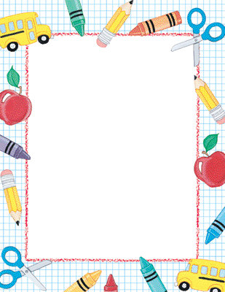

2 boxes of Kleenex  
Indoor sneakers  
Change of clothes (to be kept at school)  
1 box of large Ziplock bags  
1 box of sandwich bags

**Grade 2 School Supply List  
Millerton School  
2021-2022**

**Please put your student’s name on their personal belongings, especially sneakers, lunch bag, book bag and jackets as many come to school with identical items. Have a great summer!!!**

Pencils  
Ruler  
2 boxes of markers  
1 box of crayons  
1 box of pencil crayons  
Scissors  
3 glue sticks  
2 white erasers  
1 pack of Loose-Leaf  
1 pencil case

4 binders (2 red, 1 blue, 1 black)

6 duo-tangs (3 yellow, 1 blue, 1 orange, 1 black)

1 pack (of 4) Hilroy Scribblers

3 plastic folders (2 pockets inside)