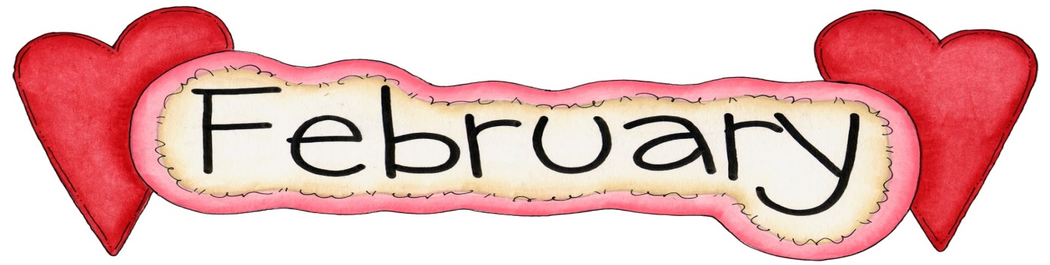

SUNDAY MONDAY TUESDAY WEDNESDAY THURSDAY FRIDAY SATURDAY
 |  |  |  | Pizza Orders Due | 1 Pizza Day  Skating  Grade 5-8 Bus will leave at 8:45 am  Bears Den  7-10 pm | 2
3 | 4 | 5 | 6 | 7 Pizza Orders Due | 8 Pizza Day  Bears Den 7-10 pm | 9
10 | 11  Teacher Staff Appreciation Week  Feb 11-Feb 15 | 12 | 13 | 14 Pizza Orders Due  Valentine’s Day  Waffle Breakfast | 15 Pizza Day  Skating K-4  Bus will leave at 8:45 am  Bears Den  7-10 pm | 16
17 | 18  Family Day  NO SCHOOL | 19 | 20  PSSC Meeting 6:00 pm  Home & School Meeting  6:30 pm | 21 Pizza Orders Due | 22 Pizza Day  Bears Den 7-10 pm | 23
24 | 25 | 26 | 27  Pink Shirt Day | 28 Pizza Orders Due | 1 Pizza Day

***Please ensure students are dressed properly for the weather and outdoor activities. Hats, mitts, winter boots, ski pants/splash pants and winter jackets.
IMPORTANT DATES: NO SCHOOL- February 18-Family Day – March Break – March 4-8.
NO SCHOOL –March 22 – Professional Learning Day.

