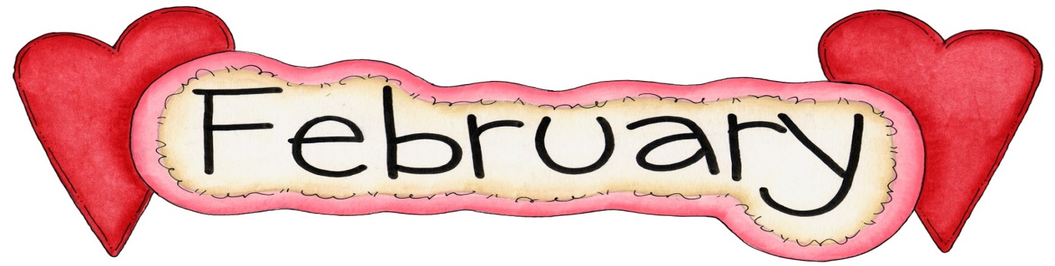

SUNDAY MONDAY TUESDAY WEDNESDAY THURSDAY FRIDAY SATURDAY
 |  |  |  | 1 Pizza Orders Due | 2 Pizza Day | 3
4 | 5 | 6  Home & School Meeting 7:00 pm | 7 | 8 Pizza Orders Due  Elementary Basketball Jamboree | 9 Pizza Day  Skating K-4  Bus will leave at 8:45 am | 10
11 | 12  Teacher Staff Appreciation Week  Feb 11-Feb 17 | 13 | 14  Valentine’s Day  Waffle Breakfast | 15 Pizza Orders Due  100th Day of School | 16 Pizza Day | 17
18 | 19  Family Day  NO SCHOOL | 20 | 21 | 22 Pizza Orders Due  Elementary Basketball Jamboree | 23 Pizza Day  Last Day of Skating for Grade 5-8 Students | 24
25 | 26  Winter Carnival Begins  Details to Follow | 27 | 28  Professional Learning Day  Early Dismissal 11:30 am

***Please ensure students are dressed properly for the weather and outdoor activities. Hats, mitts, winter boots, ski pants/splash pants and winter jackets.
IMPORTANT DATES: NO SCHOOL- February 19-Family Day – February 28-Professional Learning Day – Early Dismissal 11:30 am. March Break – March 5-9. NO SCHOOL – March 28 – Professional Learning Day and March 30 – Good Friday and April 2 – Easter Monday.

