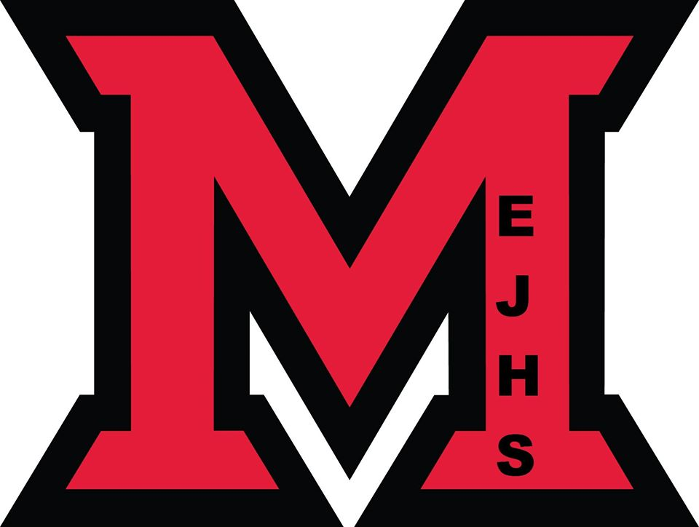
Back to School Questions…

Will Millerton students need to Bring a mask?

Yes, all students are required to bring a community mask (no bandanas or Buffs) with them to school everyday. Masks are not required in a classroom where social distancing can be respected. Masks must be worn upon entering the building and in all common areas including hallways (everywhere outside of the classroom). We are asking that students bring two clean masks with them to school.

What about the bus?
Students Grade k-5 no mask is required on the bus, but they may wear one should they choose. Students will sit one per seat unless they are in a family bubble and they will sit in the same seat every day.
For students in grades 6 to 8, masks are required if there is more than one child per seat, and those students will have to wear a mask when entering and exiting the bus. They can remove the mask if they're sitting alone or with members of the same household. Bus passes are no longer being issued.

What if I don’t come on the Bus?

Students arriving on buses will enter through the main doors. All other students will be dropped off at the elementary side entrance. We would ask that Parents use the driveway closest to the parker road and drop off their student at the base of the steps with the duty teacher. Then they would continue around the building exiting by the other driveway. Sanitizing stations will be located at each of these entrances.

Anyone entering the building, including students after morning arrival will be required to ring the doorbell, be buzzed in to the building and sign in.

When will I have to physically distance?

Students will not be physical distancing inside their class bubble.ve to stay one meter away from each other in the classroom, and two meters from everyone in common areas.

What if my parent/guardian wants to meet teacher/administrator or pick me up from school?

We will be limiting access to our building this year and we ask families to cooperate by either communicating with the school by phone 627-4090. If an in-person meeting is necessary, they are asked to call ahead and make an appointment whenever possible. If a parent needs to deliver something to a student or pick a student up for an appointment, we ask that you ring the doorbell and staff will assist you.

I heard that I am going to have to wipe my desk and chair after it is used. Is there anything else?

Students will also be expected to sanitize tools, work spaces, gym equipment, keyboards, mice and shared equipment. Students will be required to wipe outside of microwave before use.

Will the Breakfast program be running this year?

Yes, the breakfast program will be running this, but it may look different. It will start the second week of school.

How will the Cafeteria work?

In the Cafeteria, students will sit in their bubbles and the bubbles will be 2 meters apart. They will have access to microwaves; however, because of our new guidelines we are not able to provide forks, spoons or plates as we have in the past. The goody cart is not operating on startup we will be exploring ways to make this work.

What about the water-fountains?

Students are asked to bring water bottles to school this year. Water fountains will not be in use. Millerton has a water bottle filling station and two more are in the building waiting to be installed. We will also have filling station in the some of the classrooms.

When should I not go to school?

Anyone with two or more symptoms of COVID-19 must stay home and contact 811 to determine whether testing is required. If it is, the person cannot return to school until cleared by Public Health officials. If testing is not required, they can return once symptoms are absent for 24 hours (without medication), or if they have been cleared to do so by a health-care professional. If a student develops symptoms at school, they will be brought to an isolation room and home will be contacted. Students are to be picked up within an hour.

Tell me about washroom use this year.

Signage will be posted at the entrance of washrooms stating a maximum capacity of two people. Distance markers will be posted on the floor. Students are expected to practice good hand washing protocols. Teachers will manage washroom breaks to deal with possible congestion.

For the first week of school, we will follow the following schedule.

Tuesday, September 8 Grade 1,3,6.
Wednesday, September 9 Grade 2,4,7
Thursday, September 10 Grade k,5, 8
Friday, September 11 all students.

