Millerton School
December 2020

PARENT TEACHER INTERVIEWS
Parent teacher interviews are scheduled for Thursday, December 3 from 4:00 pm - 6:00 pm and Friday, December 4 from 9:00 am - 11:30 am. Parent teacher interviews will be different due to COVID-19. We are being advised by the Department of Education to not have face-to-face interviews. However, if you wish to have a teacher contact you during parent teacher interview hours, please call the school at 627-4090 to set up a time when the teacher can call you or you can email the teacher. All teacher emails are on our Millerton School web page. Thanks!

CHRISTMAS CONCERT
Our Christmas concert will look different this year. We will be having a virtual concert. A date will be announced soon for this event.

FIREPLACE DRAW
Tickets have been sent home for a draw on a Napoleon Entice™ 50” Electric Fireplace donated by Stewart’s Hearth Store as a grade 8 fundraiser. Cost is $2.00 per ticket or 3 tickets for $5.00. All tickets are due back on Thursday, December 10, 2020. The draw will be made on Friday, December 11. Good Luck to Everyone!! Thanks for all your continued support.
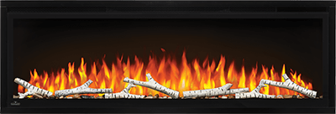

DATES TO REMEMBER
December 1 – Report Cards Issued December 4 – Parent Teacher (NO SCHOOL)
December 18 – Last Day of Classes /PJ Day January 4 – First Day of Classes

