December 2018
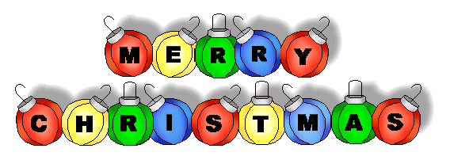

SUNDAY MONDAY TUESDAY WEDNESDAY THURSDAY FRIDAY SATURDAY
 |  |  |  |  |  | 1
2 | 3 | 4 | 5 | 6  Pizza Orders Due | 7 Pizza Day  K-4 Skating  Bus will leave at 8:45 am  Bears Den  7:00-10:00 pm | 8
9 | 10  Christmas Dinner Orders Due | 11 | 12  Christmas Dinner | 13  Pizza Orders  Due  Ugly Christmas Sweater Dance  6:00-8:00 pm  Grades 5-8 | 14 Pizza Day  Bears Den  7:00-10:00 pm | 15
16 | 17  Wear your Christmas Sweater Day | 18 | 19  Christmas Concert  9:00 am | 20  PJ Day | 21 Skating  Grades 5-8  Bus leaves at 8:45 am  Last Day of Classes  Full Day | 22
23 | 24 | 25 | 26 | 27 | 28 | 29/30/31  Classes will begin Tuesday, January 8

Millerton School: 4711 Route 108 Hwy Derby, NB. E1V-5C3. Principal: Tom McCabe, Phone # 627-4090
Dates to Remember for January: Classes begin Tuesday, January 8, 2019.

