December 2017
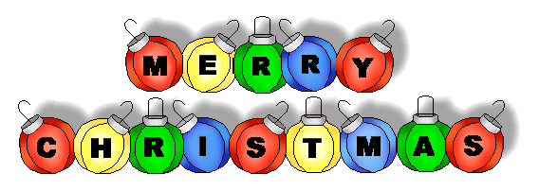

SUNDAY MONDAY TUESDAY WEDNESDAY THURSDAY FRIDAY SATURDAY
 |  |  |  | Pizza Orders Due | 1 Pizza Day  Skating  K-4  Bus leaves at 8:45 am  Bears Den  7:00-10:00 pm | 2
3 | 4 | 5 | 6 | 7  Pizza Orders Due | 8 Pizza Day  Bears Den  7:00-10:00 pm | 9 Girls Choir  2:00 pm Williamstown Church and  6:00 pm Renous Church
10 | 11  Christmas Dinner Orders Due | 12 | 13  Christmas Dinner | 14  Pizza Orders  Due  Christmas Casual Dance  6:00-8:00 pm  Grades 5-8 | 15 Pizza Day  Skating  Grades 5-8  Bus leaves at 8:45 am  Bears Den  7:00-10:00 pm | 16
17 | 18  Wear your Christmas Sweater Day | 19 | 20  Christmas Concert  9:00 am | 21 | 22 PJ Day  Last Day of Classes  Half Day  Dismissed 11:30 am | 23
24 | 25 | 26 | 27 | 28 | 29 | 30/31  Classes will begin Monday, January 8

Millerton School: 4711 Route 108 Hwy Derby, NB. E1V-5C3. Principal: Tom McCabe, Phone # 627-4090
Dates to Remember for January: Classes begin Monday, January 8, 2018.

