December | 2022

MILLERTON SCHOOL
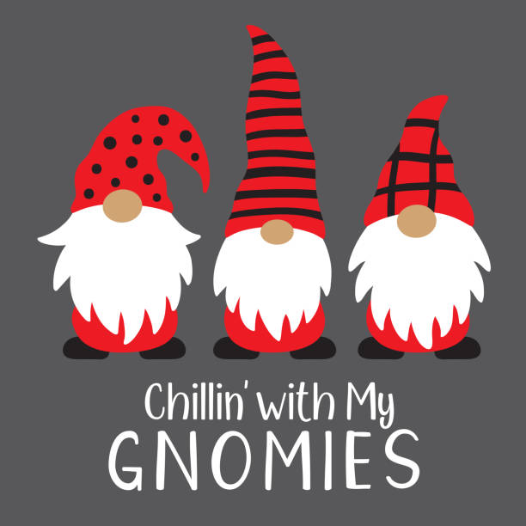
Sunday | Monday | Tuesday | Wednesday | Thursday | Friday | Saturday
 |  |  |  | 1 | 2 | 3
 |  |  |  | Report Cards Issued | NO SCHOOL  School Improvement Planning | Christmas Market  Toy Drive  Breakfast  9:00 am – 1:00 pm
4 | 5 | 6 | 7 | 8 | 9 | 10
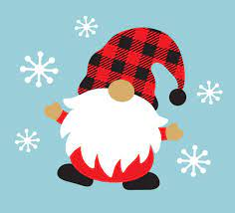 |  |  |  | Parent Teacher Interviews  4:00 – 6:00 pm | NO SCHOOL  Parent Teacher  9:00 – 11:30 am
11 | 12 | 13 | 14 | 15 | 16 | 17
 |  |  |  | Pizza Orders Due | Pizza Day  Skating  K-2 & Gr 7-8
18 | 19 | 20 | 21 | 22 | 23 | 24
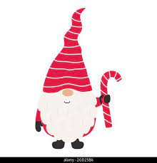 |  |  | Christmas Concert  9:00 am |  | Early Dismissal  11:30 am | Christmas Eve
25 | 26 | 27 | 28 | 29 | 30 | 31
Christmas Day | Boxing Day |  |  |  |  | New Year’s Eve
****Students Return
Jan 9, 2023

