April | 2021

MILLERTON SCHOOL
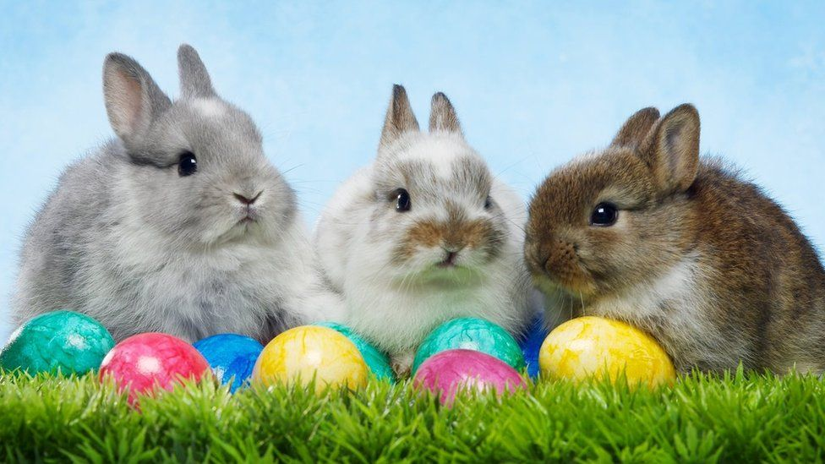
Sunday | Monday | Tuesday | Wednesday | Thursday | Friday | Saturday
 |  |  |  | 1 | 2 | 3
 |  |  |  | Spaghetti and Garlic Bread $5.00  Easter Draw | NO SCHOOL  GOOD FRIDAY
4 | 5 | 6 | 7 | 8 | 9 | 10
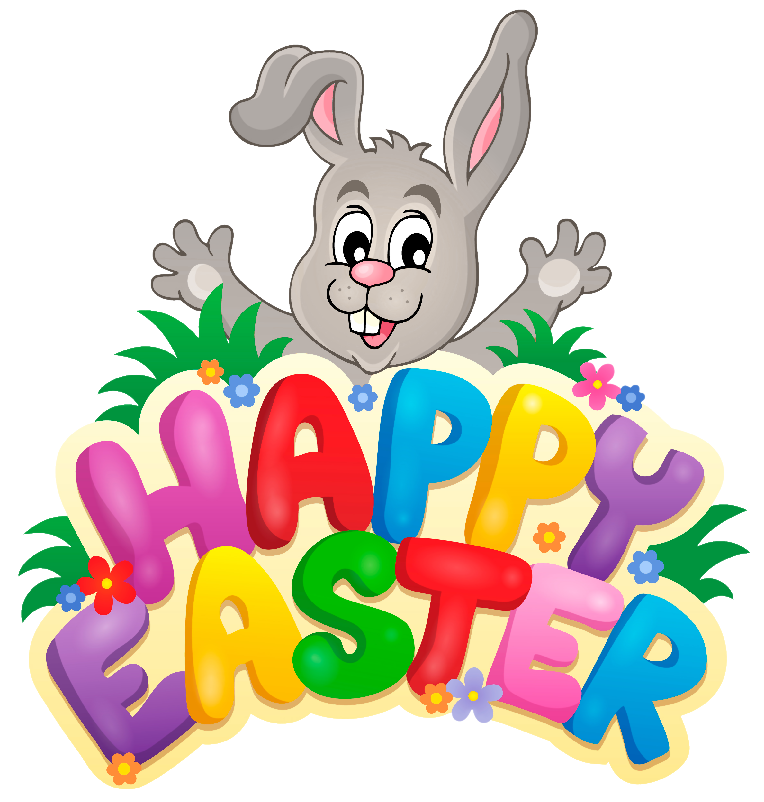 | NO SCHOOL  EASTER MONDAY |  |  | PIZZA ORDERS DUE  POPCORN $1.00 | PIZZA DAY
11 | 12 | 13 | 14 | 15 | 16 | 17
 |  |  | REPORT CARDS ISSUED | POPCORN  $1.00  Parent Teacher 4:00 – 6:00 pm | NO SCHOOL  PARENT TEACHER  9:00 – 11:30 am | 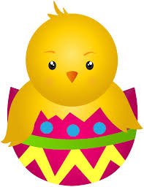
18 | 19 | 20 | 21 | 22 | 23 | 24
 |  | Grade 7 Immunization |  | PIZZA ORDERS DUE  POPCORN $1.00 | PIZZA DAY
25 | 26 | 27 | 28 | 29 | 30
 |  |  |  | PIZZA ORDERS DUE  POPCORN $1.00 | PIZZA DAY

