Millerton News
April 2018
Principal: Tom McCabe
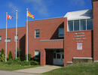

BOOK FAIR
Our Scholastic Book Fair was a huge success. We raised $368.00 in donations from the movie night.
We also sold $1833.70 in books which gives us a profit of $843.00 for our library! Thanks to Helen Wilson, for chairing this year’s Scholastic Book Fair, and a big thank you to all the parents for volunteering well over 50 hours of their time during the week to work the book fair!

ON MY WAY TO K
On My Way to K takes place on April 10, for the new students that will be attending Millerton in the fall. There will be no school that day for our kindergarten children, as Mrs. Hamilton will be helping out with the On My Way to K.

REPORT CARDS

Report cards will go home the week of April 9th. Parent teacher interviews will be held on Thursday, April 12th at 5:00—7:00 pm and Friday, April 13th at 9:00—11:30 am. Please call the office to make an appointment with your son/daughter’s teacher @ 627-4090. If you are unable to make it at these times other arrangements may be made.

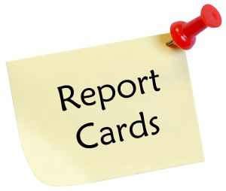

BEARS DEN
A huge thank you goes out to the Volunteers who have served at the Bear’s Den this year. Your commitment to our Middle School Students and this endeavor is very much appreciated. Thank you for making this safe, supervised event take place throughout the winter months.
Bonnie Vickers -Millerton Recreation Council

ANNUAL FREE SALE AND BREAKFAST
Once again in honor of Earth Day Millerton School will be providing a “Free Sale and Breakfast” on Saturday, April 28th from 8am -11am. Everyone is welcome to attend this event. Since it is that time of year when we start our “spring cleaning,” we are asking you to consider donating your gently used clothing, shoes, toys, books and household items to our Free Sale again this year. Bring in items you no longer want or need and discover a treasure you want to take home with you. We will be accepting donations in the Music Room from April 9th –April 24th. Thank you for your help with this worthwhile project. Remember the three R’s: REDUCE, REUSE and RECYCLE!

IMPORTANT DATES
No School - May 3, 4 - NBTA Meetings
No School - May 21 – Victoria Day
Early Dismissal – May 25 – PD Day

