Millerton News
April 2017
Principal: Tom McCabe
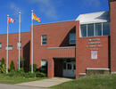

BOOK FAIR
Our Scholastic Book Fair was a huge success. We raised $200.00 in donations from the movie night.
We also sold $1898.30 in books which gives us a profit of $873.00 for our library! Thanks to Helen Wilson, for chairing this year’s Scholastic Book Fair, and a big thank you to all the parents for volunteering well over 50 hours of their time during the week to work the book fair!

ON MY WAY TO K
On My Way to K takes place on April 10, for the new students that will be attending Millerton in the fall. There will be no school that day for our kindergarten children, as Mrs. Hamilton will be helping out with the On My Way to K.

BEARS DEN
A Big THANK YOU to all those who have volunteered in the Bear's Den this year. It simply could not happen for our Middle School Students without you

PHYS.ED NOTES
April Activities for Gym:
Monday - Volleyball
Tuesday –Floor Hockey
Wednesday – Health/You and Your World
Thursday – Volleyball
Friday – Game Day
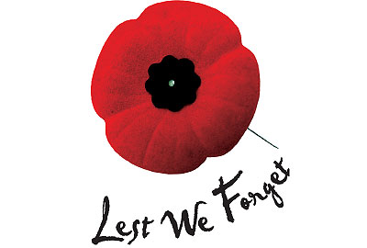
HOME AND SCHOOL NEWS
April 7 & 21 – Popcorn Day - $1.00/Bag
STEM FAIR
Congratulations to Max Green for receiving a gold ticket from the Stem Fair on Saturday, April 1, 2017 and to all the other students who participated. A job well done by all!

LEGION WINNERS FROM REMBRANCE DAY
Congratulations to Madison Daley, Caden Carter and Madison Jardine for winning in the Remembrance Day Poster/Essay contest.

READING CHALLENGE
Our reading challenge was a huge success our students did a great job reading lots of books.
Our Kindergarten, Grade 1 and 2 classes received $25.00 worth of books for their classrooms. Grade 3-8 winners received $15.00 for 1st place and $10.00 for 2nd place for reading the most pages.
Winners in Grade 3: Addison Pleadwell and Madison Daley, Grade 4: Emily Mullin and Sadie Connors, Grade 5: Gracie Richardson and Lily Doucette, Grade 6: Michaela Theriault, Taylor Foran and Madison Jardine, Grade 7: Alex Stewart and Devon Edwards, Grade 8: Emma Sturgeon and Jordan Jardine. Congratulations everyone on all your hard work!
Big thanks to our home and school committee for providing the prizes for the reading challenge.

FREE SALE AND BREAKFAST
On Saturday, April 22 our school will be celebrating Earth Day by having a free sale and breakfast.
We are asking for donations of household items, clothing, shoes, tools, toys, etc. for our free sale. This is a great way to get rid of unwanted items.

IMPORTANT DATES
No School - May 4, 5 - NBTA Meetings
No School - May 22 – Victoria Day

