Millerton News
April 2016
Principal: Tom McCabe
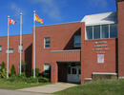

AUTISM HAT DAY
On Friday, April 8th, our school will be participating in “Autism Hat Day”. Students are permitted to wear a hat in school and contribute a small donation to Autism Resources Miramichi Inc.
BOOK FAIR
Our Book Fair will be held from April 11th to April 14th with a Movie Night on Tuesday, April 12th from 6:00–8:00 pm. More details to follow.

ON MY WAY TO K
On My Way to K takes place on April 15th, for the new students that will be attending Millerton in the fall. There will be no school that day for our kindergarten children, as Mrs. Hamilton will be helping out with the On My Way to K.

MAD SCIENCE DATES
April 4 and 11.
Last class will be on April 18.
DISTRICT ELEMENTARY STEM FAIR

The District Elementary STEM Fair will be held at Nelson Rural School on Thursday, April 14th from 12:00-4:00 pm.
BEAR’S DEN
A Big THANK YOU to all those who have volunteered in the Bear's Den this year. It simply could not happen for our Middle School Students without you. With the addition of some X-Box 360 games as well as some new board games, a good time was had by all. The biggest hit was our "New to Us" Pool table! This gently used table was generously donated by Lane and Ester Hamilton and has had waiting lines to use it since its arrival. Thanks again for another great year!

PHYS.ED NOTES
There will be a Gymnastic Display in the gym on April 5th at 10:15 am. Everyone is welcome to attend.
April Activities for Gym:
Monday – Skipping
Tuesday – Archery
Wednesday – Health Class
Thursday – Archery
Friday – Game Day (only sneakers)
Monday, Tuesday and Thursday students will need to have a change of clothes for gym for Grades 3-8.
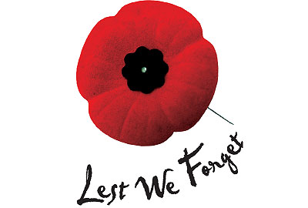
HOME AND SCHOOL NEWS
April 8 and April 22 will be our Popcorn Fridays. Cost is $1.00/Bag.
YOGA
Yoga is held every Tuesday and Thursday evenings at 6:00 pm at the school. Cost is $5.00/drop in.
IMPORTANT DATES IN MAY
No School on May 5, 6 - NBTA Meetings
No School on May 23 – Victoria Day

