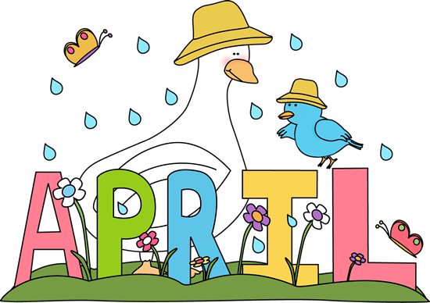

SUNDAY MONDAY TUESDAY WEDNESDAY THURSDAY FRIDAY SATURDAY
 |  |  |  |  | 1  NO SCHOOL  Parent Teacher Interviews  9:00-11:30 am | 2
3 | 4  Mad Science | 5  Yearbook orders due  Gymnastic Display 10:15 am | 6 | 7  Yearbook Photos for Teams and Grade 8  Art Club | 8  Popcorn $1.00/Bag  Autism Day  Wear a Hat  Small Donation | 9
10  April 11-April 14 | 11  Mad Science  Book Fair  Begins  Grade 7 Girls Immunization | 12  Book Fair  Movie Night for  Book Fair  6:00-8:00 pm  Details to Follow | 13  Book Fair | 14 Art Club  Last Day for Book Fair  District Elementary STEM Fair Nelson School 12:00-4:00 pm | 15  Kindergarten Students only have no school this day  On My Way to K for new students entering Kindergarten in 2016 | 16
17 | 18  Last Day for Mad Science | 19 | 20 | 21  Art Club | 22  Earth Day  Popcorn $1.00/Bag | 23  “Free Sale and Free Breakfast”  8:00 -11:00 am  Details to Follow
24 | 25 | 26 | 27 | 28  Art Club | 29 | 30

Millerton School: 4711 Route 108 Hwy Derby, NB. E1V-5C3. Principal: Tom McCabe, Phone # 627-4090
Dates to Remember for May: No School May 5, 6 and 23

