Formula Sheet for Unit 4
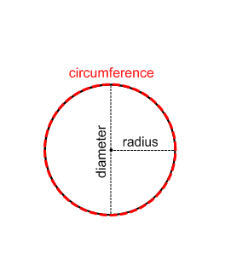
Circles
d = 2r r = d
2
c = 2πr c = πd r = c d = c
2 π π
a = πr²
d = diameter, r = radius, c = circumference, a = area, π = 3.14

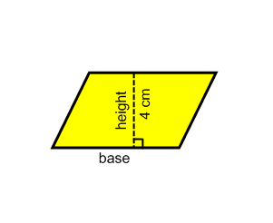
Parallelograms
a = b x h
b = a
h
h = a
b
a = area, b = base, h = height

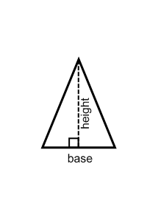
Triangles
a = b x h
2
b = 2a
h
h = 2a
b
a = area, b = base, h = height

