Short Vowels” MAKE A MATCH
https://www.starfall.com/h/ltr-sv-u/match-sv/?sn=ltr-classic
Long Vowels “MAKE A MATCH” https://www.starfall.com/h/ltr-lv-u/match-lv/?sn=ltr-classic

“FYI”
BEDTIME STORIES
Monday- “A Sick Day for Amos McGee”
https://watch.vooks.com/friendship/videos/a-sick-day-for-amos-mcgee
Tuesday- “Super Truck” https://watch.vooks.com/popular-titles-1/videos/supertruck
Wednesday- “Colors on the Farm”
https://watch.vooks.com/kidsbooks-r-presents/videos/colors-on-the-farm
Thursday- “Nom Nom Colors” https://watch.vooks.com/top-storybooks/videos/nom-nom-colors
Friday- “Opposites” https://watch.vooks.com/top-storybooks/videos/opposites

FOCUS: CVC WORDS (consonant- vowel- consonant)
“The CVC Word Song”- Version 1
https://www.youtube.com/watch?v=ZAZ74S0vPqs
Game- “Word Chain” Practice making new words. Click lever/click letter choice/drag to make new word.
https://www.turtlediary.com/game/word-chain.html

“SIGHT WORDS”
Sight Word Review with Jack Hartmann:
Kindergarten- Level A- C but feel free to practice all of them if you want to
https://www.youtube.com/watch?v=-qIxhNe5_S0&list=PLQK2XiUY9C2hzWftkn2WCyhzrb0g4DJJZ
Say the word Spell the word Print the word
1. play 2. see 3. the 4. we 5. you

Hello Boys and Girls!
I hope you enjoyed the weekend. I hope you are ready for another week of Home Learning. I think of each of you every day. I sure wish we could be together! Remember, if you need anything I am just an e-mail away marsha.hamilton@nbed.nb.ca and I will be phoning you this week.
Luv, Mrs. Hamilton
Weekly “S.T.E.A.M.” issue file:///C:/Users/hamilmal/Desktop/ASDN%20Weekly%20STEAM%20Issue%207.pdf
KINDERGARTEN HOME LEARNING MONDAY, MAY 18- FRIDAY, MAY 22, 2020
“EASY READS” “READ TO SOMEONE”
Day 1: “Pam Likes to Nap”
https://portal.flyleafpublishing.com/wp-content/uploads/books/6-Pam-Likes-to-Nap/mobile/index.html#p=2
Day 2: “Can I See Tom?”
https://portal.flyleafpublishing.com/wp-content/uploads/books/7-Can-I-See-Tom/mobile/index.html#p=18
Day 3: “We Can’t Stop!”
https://portal.flyleafpublishing.com/wp-content/uploads/books/8-We-Cant-Stop/mobile/index.html#p=4
Day 4: “Dot and Dan”
https://portal.flyleafpublishing.com/wp-content/uploads/books/9-Dot-and-Dan/mobile/index.html#p=1
Day 5: “Dot Likes to Dig”
https://portal.flyleafpublishing.com/wp-content/uploads/books/10-Dot-Likes-to-Dig/mobile/index.html#p=1

Extra Reading Material:
https://classroommagazines.scholastic.com/support/learnathome/grades-prek-k-week-4.html

REMEMBER:
PUNCTUATION NEVER TAKES A VACATION
Story: “Exclaimation Mark!”
https://www.youtube.com/watch?v=nEFMuOW5mF0
Song: “Exclaim!” https://www.youtube.com/watch?v=r4QZG71z96o

“WRITING”
“WRITING PROMPTS” Try to write 2-3 sentences for each topic
- My favorite book is… because…
- I am really good at…
- If I was the teacher, I would…
- Tonight I am going to…
- I thinks cats are…

10 FUN WAYS TO PRACTICE WRITING
- Use your finger to write in shaving cream.
- Put paint in a plastic bag and let kids write on the bag.
- Use water and a paintbrush to write letters on the driveway.
- Make letters out of Lego bricks.
- Trace letters on a friend’s back and guess what it is.
- Write letters in lemon juice on paper with a cotton swab. Use an iron or hair dryer to make the letters appear.
- Use a stick to trace letters in dirt or mud.
- Make letters out of pipe cleaners.
- Write letters on the sidewalk with sidewalk chalk.
- Use toys to make letter shapes on the floor.
“MATH” Playful Learning Activities:

“MEASUREMENT”
Length- Work on non-standard measurement with this fun and easy kindergarten math game. Cut colorful ribbons into a variety of lengths and place them in a bag. Each player pulls a ribbon from the bag, then have them compare their ribbons, identifying the longer one. The student with the longer ribbon keeps both, and the game continues.
On-line length game- https://www.topmarks.co.uk/early-years/lets-compare
Weight - Use a hanger and plastic cups to build a super simple weigh station (instructions here). Kids will love dropping items into the cups to see which weighs more or less. Turn it into a game by having them try to guess which object weighs more first or how many of one item equals another.
On-line weight game-https://pbskids.org/peg/games/happy-camel

“NUMBER SENSE”
A simple deck of playing cards can provide many ways to practice math skills. You can use them for number identification (play a memory game), sequencing (put cards in numerical order), addition (add cards together to race to 10).
On- line counting game- https://pbskids.org/peg/games/pizza-place
Ordering Numbers game-https://www.topmarks.co.uk/ordering-and-sequencing/coconut-ordering

1. Pick a color. See how many objects you can find in your home that are the same color.
2. Hide an object. Use positional language (above, below, behind, etc. to give clues for your child to find the object.
3. Sort silverware and put away.
4. Roll two dice. Count out sets for each. Then add them together and count how many in all.
5. Use small toys or animal figures to make up and act out addition and subtraction stories.

“3D SHAPES”
Use play-doh and toothpicks to build 3D shapes. 7 Shape Activities: https://www.education.com/games/play/?childId=-1#math,math-preschool,shapes-p

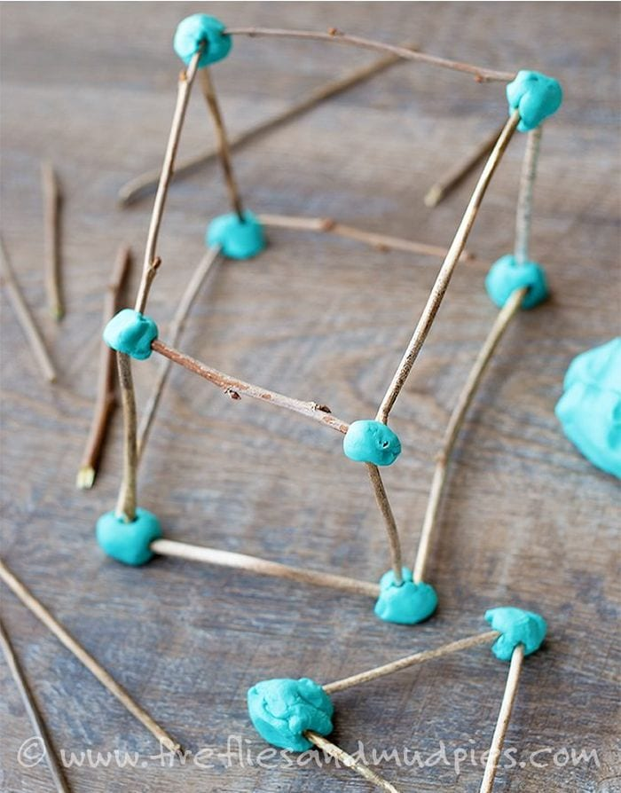

“MATH STORIES”
- NUMBER SENSE
“Diego and the Floating Donut”- https://mathstory.com/youtube-math-videos/diego-and-the-mysterious-floating-donut/
- SHAPES
“Mouse Shapes-” https://www.youtube.com/watch?v=GysjOAZzvz0
- MEASUREMENT
“Tessy and Teddy’s Clothes Shop” -https://www.youtube.com/watch?v=RXCc4voREDY
- MORE
“Cake Party at Bear’s House”- https://www.youtube.com/watch?v=R8H9VxyrvMs
- LESS
“Chef Mouse the Master Chef”- https://www.youtube.com/watch?v=_m3d07iljNM

“FOR FUN”
- “Whack a Difference” game:
http://www.mathgametime.com/games/whack-a-difference
- “Down by the Bay”-song- The Learning Station:
https://www.youtube.com/watch?v=Yt1czlnCUCg
Now it’s YOUR turn to sing. These are some different rhymes I came up with. Can you think of any?
Did you ever see a flower taking a shower?
Did you ever see a peach rolling down the beach?
Did you ever see a shark playing at the park?
- “Dino Dig” – yummy and fun!!!!!
Create your own archeological dinosaur dig with this fun sensory treat! Dig like a real scientist through the jello Earth layers to dig up your dinos.
https://team-cartwright.com/sensory-dinosaur-dig/
- Great craft idea for these windy days! “WATER BOTTLE WIND SPIRALS” https://www.cbc.ca/parents/play/view/water-bottle-wind-spirals

Lots more fun at https://www.cbc.ca/kidscbc2/ Check it out!
HAVE FUN AND STAY TUNED FOR MORE FUN HOME LEARNING ACTIVITIES NEXT WEEK

