KINDERGARTEN HOME LEARNING MAY 25- MAY 29, 2020
“FYI” “S.T.E.A.M” http://stemnorth.nbed.nb.ca/sites/stemnorth.nbed.nb.ca/files/doc/y2020/May/asdn_weekly_steam_issue_8.pdf
I like this activity from the weekly “STEAM” issue:
Read the book- “Not a Stick”- https://www.youtube.com/watch?v=xpMBQnCuJCQ
It’s your turn to be an illustrator /author of your own ‘Not a Stick’ book. In nature, find mini sticks to glue into a book of paper you stapled together. What is your stick going to turn into? We would love to see where your imagination takes you. Share your story on Facebook @STEAM in ASD-N or on Twitter @STEMNorth.

“BEDTIME STORIES”
“The Bear Ate Your Sandwich”- https://www.youtube.com/watch?v=MRhtZ8DspaE&feature=youtu.be
“My Friend Maggie”- https://www.youtube.com/watch?v=QZAX6kZkoE8&feature=youtu.be
“Splish, Splash, Splat”- https://www.youtube.com/watch?v=fSE_mxIOYqE
“Silly Suzy Goose”- https://vimeo.com/55479841
“Please please the Bees”- https://www.storylineonline.net/books/please-please-bees/

“SIGHT WORDS”
Sight word review with Jack Hartmann:
Kindergarten- Level A-C- but feel free to practice all levels if you want to
https://www.youtube.com/watch?v=-qIxhNe5_S0&list=PLQK2XiUY9C2hzWftkn2WCyhzrb0g4DJJZ
“SPELLING”
Say the word, Spell the word, Print the word
1. am 2. come 3. here 4. in 5. look

“WORD WORK” – You might need to click “Get Adobe Flash Player”
Day 1: “Puzzle Me Words” http://www.readwritethink.org/files/resources/interactives/puzzlemewords/
Day 2: “Construct Words” http://www.readwritethink.org/files/resources/interactives/construct/
Day 3: “In the Bag” http://www.readwritethink.org/files/resources/interactives/in_the_bag/
Day 4: “Word Family” http://www.readwritethink.org/files/resources/interactives/wordfamily/
Day 5: “Word Wizard” http://www.readwritethink.org/files/resources/interactives/wordwizard/
Review:
“ABC Match”/ “Picture Match”
http://www.readwritethink.org/files/resources/interactives/abcmatch/
http://www.readwritethink.org/files/resorces/interactives/picturematch/

“READING”
Day 1- “Color the Rainbow”
https://www.storyplace.org/story/color-rainbow
https://www.storyplace.org/activity/what-color-it
Day 2- “Bananas for Lunch”
https://www.storyplace.org/story/bananas-lunch
https://www.storyplace.org/activity/count-bananas
Day 3- “What Should Fran Wear?”
https://www.storyplace.org/story/time-fight-fire
https://www.storyplace.org/activity/what-should-fran-wear
Day 4- “Clyde’s Smile
https://www.storyplace.org/story/clydes-smile
https://www.storyplace.org/activity/5-hungry-crocs
Day 5- “The Yellow Gorilla”
https://www.storyplace.org/story/yellow-gorilla
https://www.storyplace.org/activity/baby-gorilla-goes-shopping

“WRITING” 10-20 minutes/day is reccommended
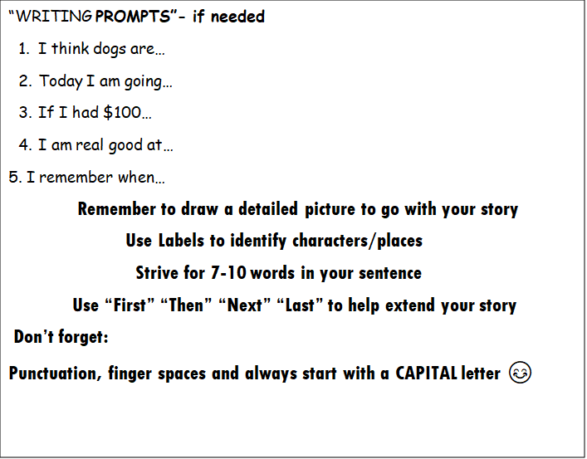

Practice Capitalization and Punctuation by re-writing the sentences (on the next page) properly
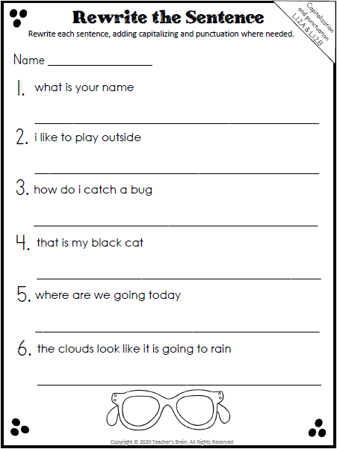

MATH STORIES:
- “The Best Vacation Ever” https://www.youtube.com/watch?v=IjOway5VuqM
2. “Animals on Board” https://www.youtube.com/watch?v=tbvPvhrpSgM
3. “Sunflowers Measure Up” https://www.youtube.com/watch?v=vVaSEU8bUJU
4. “Addition Annie” https://www.youtube.com/watch?v=mqVbFbBK95Q
5. “Eggs and Legs” Counting by 2 https://www.youtube.com/watch?v=4rOa-mncdEw

MATH CONCEPT this Week is “Number Bonds” also known as “Number Pairs”- part-part-whole

“Number Bonds to 3” song- Jack Hartmann https://www.youtube.com/watch?v=vh481gFiqQk
“Number Pairs to 4” song- Jack Hartmann https://www.youtube.com/watch?v=P2gwD4QOD0E
“Number Bonds to 5” song- Jack Hartmann https://www.youtube.com/watch?v=y1oa6o0fMKk
Games:
https://www.abcya.com/games/fuzz_bugs_number_bonds
https://www.helpfulgames.com/subjects/mathematics/number-bonds.html (#3)
https://www.helpfulgames.com/subjects/mathematics/number-bonds.html (#4)
https://www.helpfulgames.com/subjects/mathematics/number-bonds.html (#5)
Counting Practice: counting
http://www.hbschool.com/activity/rubber_count_to_10/
http://resources.hwb.wales.gov.uk/VTC/2008-09/maths/irf08_15/english/Flash/Activity_8/trefnu_rhifau_index.html

