Dear Families,

I know that everyone has had to adjust to a lot of changes this term and I want to thank -you for all your hard work and co-operation.

Attached you will find some activities to continue learning throughout the summer.

These resources are NOT meant to add to your stress. If it does, then please set it aside. It's intended for anyone looking for some additional learning ideas and remember, you can always go back to my weekly “Home Learning” activities as a review or to work on things you didn’t get to.

It’s important to keep your family happy, healthy, and safe. Reading, playing, talking, and getting outside in the fresh air are important for all of us!

Focus on that and know you did a fabulous job during this situation!

Please let me know if I can help in any way ([marsha.hamilton@nbed.nb.ca](mailto:marsha.hamilton@nbed.nb.ca)).

I miss your children very much!

Sincerely,

Mrs. Hamilton 😊

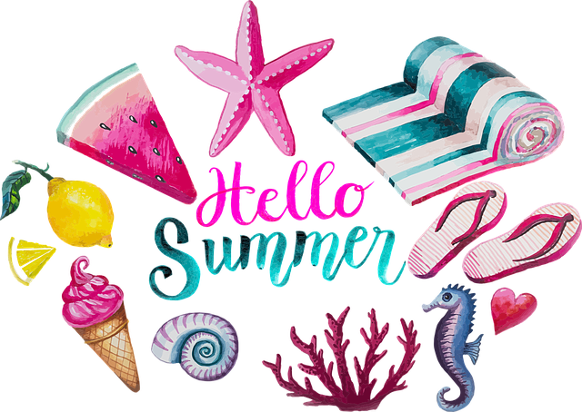

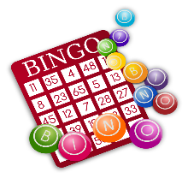

10 FREE Sites to Practice Reading

1. Between the Lions
2. Starfall
3. StoryPlace
4. StoryLine Online
5. ReadWriteThink Student Interactives
6. PBS Reading Games
7. WordWorld
8. Storynory
9. OxfordOWL
10. ABCya

Find them all here: <https://wehavekids.com/education/elementary-reading-websites-for-kids>



“SUMMER READING CHALLENGE”

Are you up for this challenge? Can you read 100 books this summer? If so, go to: <file:///C:/Users/marsha.hamilton/Desktop/Summer%20Reading%20Challenge.pdf>

OR how about a game of “SUMMER READING BINGO” file:///C:/Users/marsha.hamilton/Desktop/Reading%20Bingo.pdf

Feeling creative, fill in your own “BINGO” card 😊

<https://drive.google.com/file/d/0B3TmdKv-sx60VnpEazZ1MHNOU00/view>

“SUMMER LEARNING ACTIVITIES”

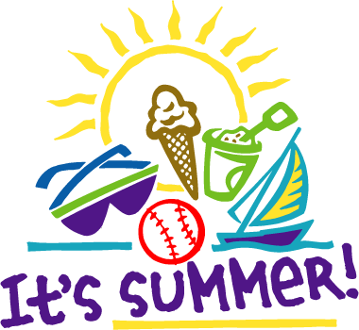

[This Photo](https://askanesthetician.wordpress.com/2011/06/21/sun-protection-101/) by Unknown Author is licensed under [CC BY-ND](https://creativecommons.org/licenses/by-nd/3.0/)

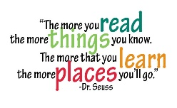

“BEDTIME STORIES”

<https://www.tumblebooklibrary.com/Home.aspx?categoryID=77>

Excellent Site- Lots of books to watch online

USERNAME: millerton PASSWORD: trial

1 2 3 MATH is FUN!!!

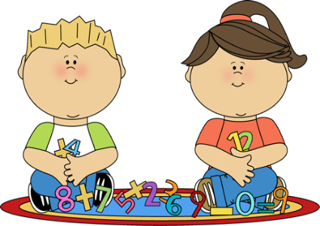

Math Skills Practice:

<https://on.mathgames.com/kindergarten>

“Splash Learn”-sign up for FREE

<https://www.splashlearn.com/math-games-for-kindergarteners>

”WRITING”

Keep a journal of all your summer adventures. Make your own, buy one at the Dollar Store or print this one.

<file:///C:/Users/marsha.hamilton/Desktop/Free%20Journal%20Paper%20Samples.pdf>

Happy Writing

LEVEL C

and

are

come

for

got

here

not

play

said

you

LEVEL B

dad

he

in

it

look

mom

my

on

up

we

LEVEL A

am

at

can

go

is

like

me

see

the

to

**BE SURE TO REVIEW THE SIGHT WORDS**

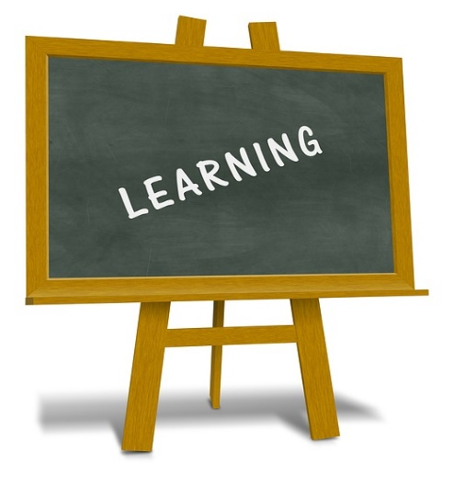

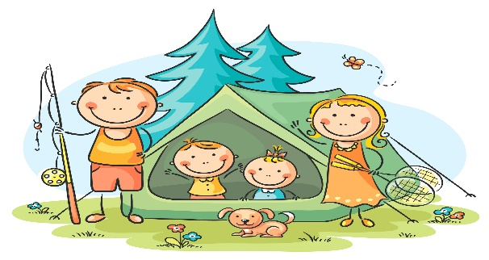

[This Photo](http://www.orientacionandujar.es/2013/06/14/aprendizaje-cooperativo-metodologia-didactica-para-la-escuela-inclusiva/) by Unknown Author is licensed under [CC BY-SA-NC](https://creativecommons.org/licenses/by-nc-sa/3.0/)

“SIGHT WORDS” with Jack Hartmann

Level A <https://www.youtube.com/watch?v=-qIxhNe5_S0>

Level B <https://www.youtube.com/watch?v=4O5aHNnQLgE>

Level C <https://www.youtube.com/watch?v=RDBKwChlunQ>

**ENJOY YOUR SUMMER VACATION 2020**