“Home Learning” Week 2 April 13-17
LITERACY:
“Outdoors Alphabet Hunt”
Make learning the alphabet an active learning experience! Head outdoors and go on an alphabet hunt. When you find something that begins with a certain letter, shout it out, write it down or take a picture of it. Keep it simple. Find 3 (or 5, or 10) letters each time you go for a walk. Can you find any numbers? (it’s harder than you may think!)
Hint: Look everywhere- up, down, at small things and large things, at things that are nearby or far away.

Happy hunting!
Here are a few pictures of “letters” I found when I went on my “Alphabet Hunt”
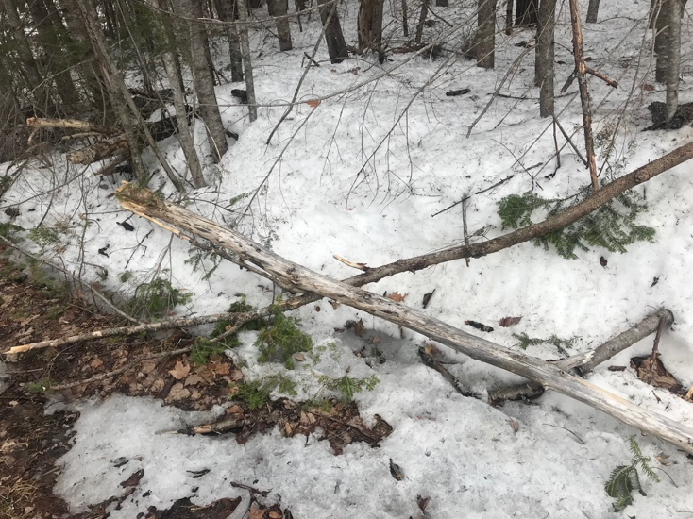
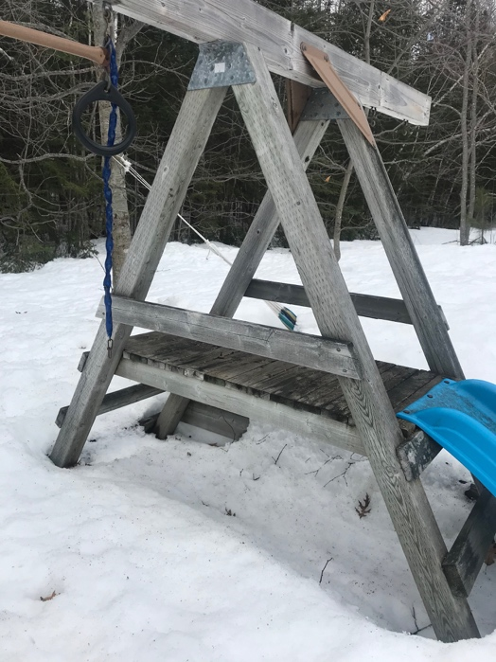
X
A

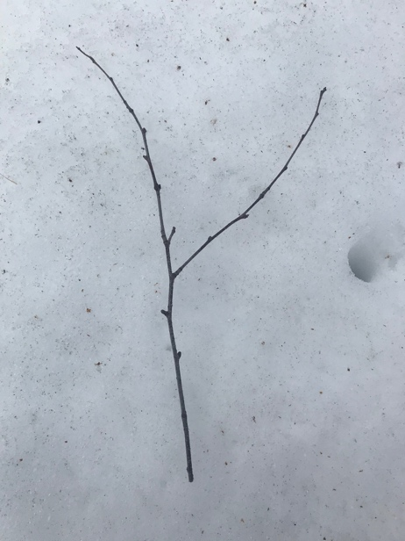
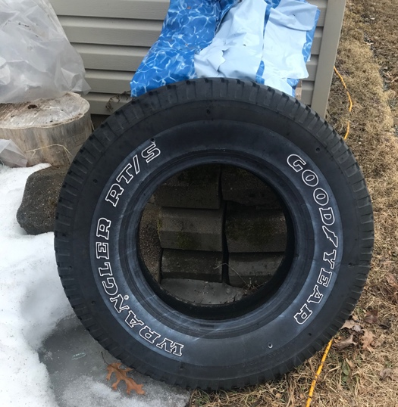
O
Y
READING:
Let’s review the vowels sounds with this song:
- https://www.youtube.com/watch?v=dEbaEXf6BqM “Old MacDonald Had Some Vowels”
Practice reading the short vowel sounds with “Vowel Pals” story books at:
- https://www.starfall.com/h/vowelpals/ vowel pals story books

“Reading Tips” for Parents:
WRITING:
Write/ illustrate about some fun things you and your family are doing each day. Remember- “Punctuation Never Takes a Vacation”
MATH:
Kindergarten love working with patterns. We worked on identifying, reproducing, extending and creating patterns (2-3 objects- AB, ABC patterns) and talked about the “core” of the pattern- the part that repeats. They are awesome at patterning and they love to be challenged. I hope that they (and you) will enjoy the games and activities I have provided.
Here is a link that explains the pattern concepts we have talked about in class. Sit back, relax and enjoy discussing these with your child.
- http://www.linkslearning.k12.wa.us/kids/1_Math/2_Illustrated_Lessons/5_Patterns/index.html
Song- https://www.youtube.com/watch?v=-NdzJg3moRY “Patterns are Everywhere”

Here are some fun activities for making “Patterns” outside:
1. Creating and Extending Chalk Patterns
Start a pattern on the sidewalk or let your child create their own.

2. Patterns with Nature
Collect rocks, leaves, pinecones, acorns, etc.
What kinds of patterns can you create?

3. Patterns with Our Bodies
One person picks a movement (ex. clap) and then the next person picks something else (ex. jump) and then you have a pattern to repeat. . .

