Millerton School
Grade One Supplies
2015-2016
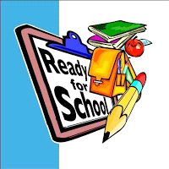
Binders (1”) Pencils HB#2
Math- Blue Ruler
Writing- Red 1 Box of Markers (pkg.of 8 Crayola)
Printing- Blue 1 Box of Crayons or Pencil Crayons
Duotangs Scissors
Literacy- Yellow 2 Glue Sticks
Spelling- Orange 2 White Erasers
Poetry- Blue 1 Pencil Case
You and Your World- Black Indoor Sneakers (non-marking)
Vocabulary- Yellow 1 Box of Kleenex
1 Scribbler (any color)
2 Two- Pocket Folders

Please have your child’s name on their personal belongings, especially sneakers, lunch bag, book bag and jackets as many come with the identical items.
Have a wonderful summer!!
Mrs.Simpson

