Grades 4 & 5



Grades 4 & 5 Ctd.

Writing

This week’s writing genre focuses on opinion writing. See resources and digital lessons below.

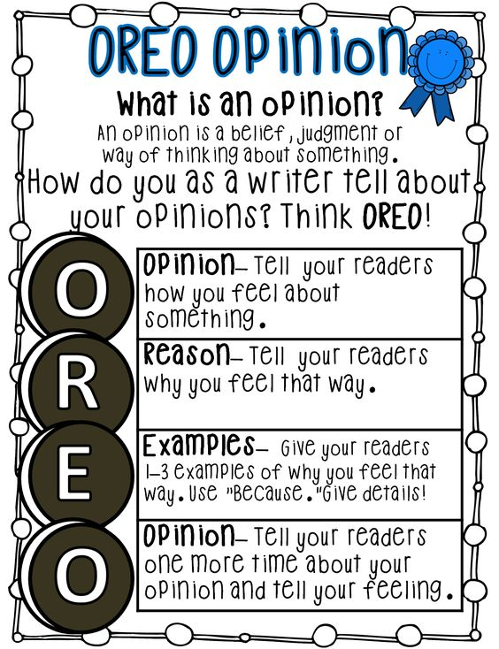

View the following three teaching videos on how to write an opinion piece:

1. Episode 1: What is an opinion piece?

Link: <https://www.youtube.com/watch?v=KEK2oGBSsHk>

1. Episode 2: Choosing an opinion writing topic

Link: <https://www.youtube.com/watch?v=qv4rHG6rrr8>

1. Episode 3: Making an opinion writing plan

Link: <https://www.youtube.com/watch?v=7kYtkqfXMOg>

Now choose an opinion writing topic and print off the graphic organizer below to make your opinion writing plan.

Grades 4 & 5 Ctd.

**Opinion Writing Graphic Organizer**

|  |  |
| --- | --- |
| **REASON #1**  **Topic** | **REASON #2** |
| **REASON #3** | **REASON #4** |

Grades 6-8

|  |  |  |
| --- | --- | --- |
| What occasions did you celebrate so far during this pandemic? Make a list. Choose 1 or 2 and explain how you celebrated this year compared to how you would normally celebrate. Which was better? | Interview a parent or another adult. Ask them what their biggest change has been and what they are most thankful for. Ask their top 3 moments from this experience. | Choose any TV show or movie. Write the title, characters, setting, beginning, middle, and end. Write an alternate ending for this show or movie. |
| page7image14408Make a T-chart. Write a list of things you like about learning at home versus at school. | What movies have you watched during the last 2 months? What genre do you prefer? Make a list of all the movies you have watched this month and then choose 2 to compare. | Billie Ellish said “In the public eye, girls and women with strong perspectives are hated. If you're a girl with an opinion, people just hate you. There are still people who are afraid of successful women, and that's so lame.” Write a response stating if you agree or disagree with her and explain why. |
| Mother’s Day was this month. Take time to write a letter to your mom, grandmother, aunt or a special friend. Tell them why you are grateful to have them in your life. Do something special to show you are thankful such as washing the dishes, helping cook a meal or giving them a special hug. | Read your book while doing a wall sit. How long can you do it for? Try reading while doing a plank. Which is easier? Try to increase your time for both. Write a summary in your journal of what you read while doing the wall sit and plank. | Pick a page from the book you are reading. Change all of the nouns to things you see right in front of you in your house, then read it aloud. |