**PHYSICAL EDUCATION DIGITAL CHOICE BOARD**

Grade Level: K-8  
Subject: Physical Education

**Hey Millerton Bears. Use this choice board for the next 2 weeks to help reach your 60 minutes of daily physical activity. Don’t forget to log your activity with all the exercise you complete at home. Bring you completed log back upon your return to school to be evaluated, thanks and take care.**

|  |  |  |
| --- | --- | --- |
| **Obstacle Course**  Design your indoor or outdoor obstacle course | **Dance Party** Get your heart beating and dance with the  [GoNoodle](https://www.youtube.com/watch?v=WVEDSzH2Clc&list=PLAwOTEJXH-cOIzhyYryScyGVT5azY3FGi) Crew. Aim for 15 minutes per day. | **Spell Your Name Fitness.**  Spell out your name and do the activities that go with each letter. See directions below. |
| **Tabata**  See directions below and do 3-5 rounds of Tabata. | **Cosmic Yoga**  Go to [Cosmic Yoga](https://www.youtube.com/c/CosmicKidsYoga) and choose a yoga routine. Try to do 3-5 routines each week. | **Scavenger Hunt**  Go on a scavenger hunt around your neighborhood using the list below.  Winter Scavenger Hunt | Indoor Play for Kids | Melissa &amp; Doug Blog |
| **Walk the Block**  Take a walk around the block with your family. Pick an exercise to do at each stop sign. | **Fitness Shuffle**  Use half a deck of cards. Draw one card and see what exercise you get to do! See directions below. | **Winter Challenge**  How many winter activities can you do in 2 weeks? See list below. |













Scavenger Hunt

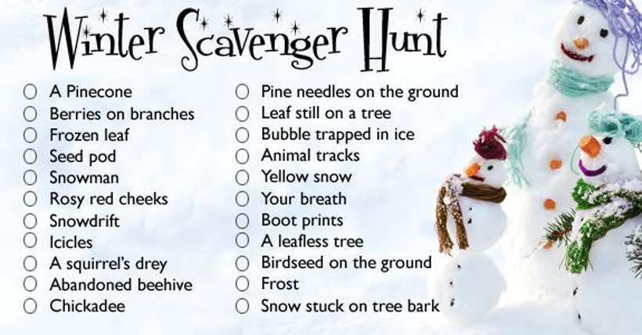

Winter Challenge Checklist

Go Sledding.

Go skating on an outdoor rink

Build a snowman

Build a quinzhee or snowfort

Go snowshoeing

Go cross country skiing

Build a snow sculpture

Go on a winter hike

Build an outdoor fire (have a parent help)

Cook lunch/supper over an outdoor fire.

*If you are looking for more fun winter activities, check out this website. <https://kidactivities.net/games-play-snow/>